Operating System Concepts

By:
Sandeep Goud Alvala

____________________________________________________________
General

1.What do you understand by System Calls? How System Call Works? How the context
switching is related to System call?
Ans:
System calls:
The interface to the kernel is a layer of software called ‘System Calls’. These calls are defined by the underlying operating system and may not be fully portable.
The system calls are also termed as the entry points to the kernel and are not linked to application programs. The application code that is heavily dependent on system calls tend to be less portable across operating system.
Since the system calls are part of the OS, the application programs need to context switch from user sapce to kernel space (also termed as 'privilaged mode' or 'superuser mode') whenever a system call is invoked. This translates into an additional start-up overhead when compared with a library function.
Working:
From a programmer point of view, calling a system call is equivalent to calling any normal C function.
- Inside the Linux kernel, each system call has a number associated with it.
- The kernel expects all the information like system call number, the arguments to the system call etc to be present in CPU registers.
- A system call first invokes a C library wrapper function which does all this work of placing the information required to be placed in CPU registers. The system call number is placed in the register %eax.
- After doing the above work, the same wrapper function invokes a trap instruction 'int 0x80'. This instruction switches the processor mode from user mode to the kernel mode and executes the code kept at location 0x80. Note : Starting with Linux kernel 2.6 and glibc 2.3.2 a faster mechanism of using the 'sysenter' instruction is followed to switch into the kernel mode.
- After the above step, now since the processor is in kernel mode, the kernel calls a general trap handler function system_call() to handle this trap.
- This handler function :
- The system call service routine that is finally called by the trap handler first checks the validity of the arguments sent to it and then it does the actual work requested by the application.
- Once the system call service routine is done with its processing, the control is returned back to the trap handler function which returns the flow back to the wrapper function in the user-mode.
- Based on the return value from the trap handler, the wrapper function sets the 'errno' variable and returns -1 (in most of the cases) to indicate an error.
- The value of the 'errno' variable is assigned by negating the return value of the trap handler (returned to wrapper function).
- The application can use the strerror() API with 'errno' to get the error information in form of human readable string.
2.How to add new system call into the Kernel? What are the various steps involved?
Ans:
Step 1: Get the source
The first step is to download the source code of the Linux kernel. I used the one available from the repositories but feel free to get the sources from kernel.org.
$ apt-get source linux-image-$(uname -r)
This would download all the archives and unpack it into a directory linux-3.2.0.
Step 2: Add system call to system call table
Open the file arch/x86/kernel/syscall_table_32.S and add the following line.
.long sys_hello
Step 3: Define macros associated with system call
Open the file arch/x86/include/asm/unistd_32.h. You will notice that a macro is defined for each system call. At the end of the huge macro definition, add a definition for our new system call. I added the following line:
#define __NR_hello 349
and accordingly incremented the value of the macro NR_SYSCALLS:
#define NR_Syscalls 350
Also, add the macro definition to the file arch/x86/include/asm/unistd_64.h
#define __NR_hello 312
__SYSCALL(__NR_hello, sys_hello)
Now to the file include/linux/syscalls.h, add the prototype of the system call.
asmlinkage long sys_hello(void);

Now, in the root directory of the kernel sources, create a directory named hello and in it, a file hello.c with the following content:
#include <linux/kernel.h>

asmlinkage long sys_hello(void)
{
printk("Hello world\n");
return 0;
}
printk is similar to printf function of C but writes to the kernel log instead of the screen. asmlinkage is a key word used to indicate that all parameters of the function(here none of course 🙂 ) would be available on the stack.
After creating the function definition, create a file named Makefile within the hello directory and the following content to the file:
obj-y := hello.o
This is to ensure that our hello.c file is compiled and included in the kernel.
Now, to the Makefile in the root directory of the kernel sources, edit the following line:
core-y += kernel/ mm/ fs/ ipc/ security/ crypto/ block/
to:
core-y += kernel/ mm/ fs/ ipc/ security/ crypto/ block/hello
This is to tell the compiler that the source files of our new system call are in present in the hello directory.
That’s it-you have added your own system call! Now all you need to compile the kernel. [1] is a good place to get information on how to compile the kernel. You needn’t do all the steps since you have the sources-read it carefully :)!
After you compile and reboot into the kernel you just compiled, try running the following program.
#include <stdio.h>
#include <linux/kernel.h>
#include <sys/syscall.h>
#include <unistd.h>

#define __NR_hello 312 //349 if you are running a 32bit kernel and following my tutorial

long hello_syscall(void)
{
return syscall(__NR_hello);
}

int main(int argc, char *argv[])
{
long int a = hello_syscall();
printf("System call returned %ld\n", a);
return 0;
}
The output of the program would be:
System call returned 0
The printk’s output get written to the kernel log. To view it, run the command
$dmesg

3.Explain Linux Booting Process? Why do you need X-Loader?
Ans: Press the power button on your system, and after few moments you see the Linux login prompt.
Have you ever wondered what happens behind the scenes from the time you press the power button until the Linux login prompt appears?
The following are the 6 high level stages of a typical Linux boot proces
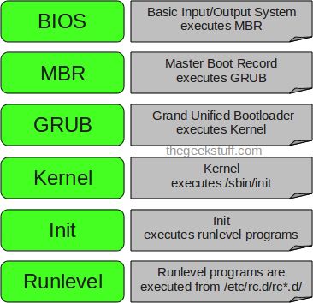

1. BIOS
- BIOS stands for Basic Input/Output System
- Performs some system integrity checks
- Searches, loads, and executes the boot loader program.
- It looks for boot loader in floppy, cd-rom, or hard drive. You can press a key (typically F12 of F2, but it depends on your system) during the BIOS startup to change the boot sequence.
- Once the boot loader program is detected and loaded into the memory, BIOS gives the control to it.
- So, in simple terms BIOS loads and executes the MBR boot loader.
2. MBR
- MBR stands for Master Boot Record.
- It is located in the 1st sector of the bootable disk. Typically /dev/hda, or /dev/sda
- MBR is less than 512 bytes in size. This has three components 1) primary boot loader info in 1st 446 bytes 2) partition table info in next 64 bytes 3) mbr validation check in last 2 bytes.
- It contains information about GRUB (or LILO in old systems).
- So, in simple terms MBR loads and executes the GRUB boot loader.
3. GRUB
- GRUB stands for Grand Unified Bootloader.
- If you have multiple kernel images installed on your system, you can choose which one to be executed.
- GRUB displays a splash screen, waits for few seconds, if you don’t enter anything, it loads the default kernel image as specified in the grub configuration file.
- GRUB has the knowledge of the filesystem (the older Linux loader LILO didn’t understand filesystem).
- Grub configuration file is /boot/grub/grub.conf (/etc/grub.conf is a link to this). The following is sample grub.conf of CentOS.
#boot=/dev/sda
default=0
timeout=5
splashimage=(hd0,0)/boot/grub/splash.xpm.gz
hiddenmenu
title CentOS (2.6.18-194.el5PAE)
root (hd0,0)
kernel /boot/vmlinuz-2.6.18-194.el5PAE ro root=LABEL=/
initrd /boot/initrd-2.6.18-194.el5PAE.img
- As you notice from the above info, it contains kernel and initrd image.
- So, in simple terms GRUB just loads and executes Kernel and initrd images.
4. Kernel
- Mounts the root file system as specified in the “root=” in grub.conf
- Kernel executes the /sbin/init program
- Since init was the 1st program to be executed by Linux Kernel, it has the process id (PID) of 1. Do a ‘ps -ef | grep init’ and check the pid.
- initrd stands for Initial RAM Disk.
- initrd is used by kernel as temporary root file system until kernel is booted and the real root file system is mounted. It also contains necessary drivers compiled inside, which helps it to access the hard drive partitions, and other hardware.
5. Init
- Looks at the /etc/inittab file to decide the Linux run level.
- Following are the available run levels
  - 0 – halt
  - 1 – Single user mode
  - 2 – Multiuser, without NFS
  - 3 – Full multiuser mode
  - 4 – unused
  - 5 – X11
  - 6 – reboot
- Init identifies the default initlevel from /etc/inittab and uses that to load all appropriate program.
- Execute ‘grep initdefault /etc/inittab’ on your system to identify the default run level
- If you want to get into trouble, you can set the default run level to 0 or 6. Since you know what 0 and 6 means, probably you might not do that.
- Typically you would set the default run level to either 3 or 5.
6. Runlevel programs
- When the Linux system is booting up, you might see various services getting started. For example, it might say “starting sendmail …. OK”. Those are the runlevel programs, executed from the run level directory as defined by your run level.
- Depending on your default init level setting, the system will execute the programs from one of the following directories.
  - Run level 0 – /etc/rc.d/rc0.d/
  - Run level 1 – /etc/rc.d/rc1.d/
  - Run level 2 – /etc/rc.d/rc2.d/
  - Run level 3 – /etc/rc.d/rc3.d/
  - Run level 4 – /etc/rc.d/rc4.d/
  - Run level 5 – /etc/rc.d/rc5.d/
  - Run level 6 – /etc/rc.d/rc6.d/
- Please note that there are also symbolic links available for these directory under /etc directly. So, /etc/rc0.d is linked to /etc/rc.d/rc0.d.
- Under the /etc/rc.d/rc*.d/ directories, you would see programs that start with S and K.
- Programs starts with S are used during startup. S for startup.
- Programs starts with K are used during shutdown. K for kill.
- There are numbers right next to S and K in the program names. Those are the sequence number in which the programs should be started or killed.
- For example, S12syslog is to start the syslog deamon, which has the sequence number of 12. S80sendmail is to start the sendmail daemon, which has the sequence number of 80. So, syslog program will be started before sendmail.

4.What is difference between GPOS (General Purpose Operating System) and Special
Purpose Operating System such as RTOS?
Ans:
GPOS
1.It is used in multiuser environment
2.protected memory model
3.non scalable
4.high interrupt latency
5.time insensitive
RTOS
1.it is dedicated to a single work
2.flat memory model
3.scalable
4.low interrupt latency
5.time sensitive
5.How crash is different from panic?
Ans:
6.How user space is different from kernel space?
Ans: The random access memory (RAM) can be divided into two distinct regions namely - the kernel space and the user space.
The kernel runs in the part of memory entitled to it. This part of memory cannot be accessed directly by the processes of the normal users, while as the kernel can access all parts of the memory. To access some part of the kernel, the user processes have to use the predefined system calls i.e. open, read, write etc. Also, the C library functions like printf call the system call write in turn.
The system calls act as an interface between the user processes and the kernel processes. The access rights are placed on the kernel space in order to stop the users from messing up with the kernel, unknowingly.
So, when a system call occurs, a software interrupt is sent to the kernel. The CPU may hand over the control temporarily to the associated interrupt handler routine. The kernel process which was halted by the interrupt resumes after the interrupt handler routine finishes its job.
7.What are the main modules to implement OS Kernel Functionalities?
Ans: Modules:
There are a few commands that allow you to maniuplate the kernel. Each is quickly described below, for more information say `man [command]`.
- depmod - handle dependency descriptions for loadable kernel modules.
- insmod - install loadable kernel module.
- lsmod - list loaded modules.
- modinfo - display information about a kernel module.
- modprobe - high level handling of loadable modules.
- rmmod - unload loadable modules.
8.What are the different types of Kernels?
Ans: Kernels may be classified mainly in two categories
1.Monolithic,2.Micro Kernel

- Monolithic Kernels
Earlier in this type of kernel architecture, all the basic system services like process and memory management, interrupt handling etc were packaged into a single module in kernel space. This type of architecture led to some serious drawbacks like 1) Size of kernel, which was huge. 2) Poor maintainability, which means bug fixing or addition of new features resulted in recompilation of the whole kernel which could consume hours
In a modern day approach to monolithic architecture, the kernel consists of different modules which can be dynamically loaded and un-loaded. This modular approach allows easy extension of OS's capabilities. With this approach, maintainability of kernel became very easy as only the concerned module needs to be loaded and unloaded every time there is a change or bug fix in a particular module. So, there is no need to bring down and recompile the whole kernel for a smallest bit of change. Also, stripping of kernel for various platforms (say for embedded devices etc) became very easy as we can easily unload the module that we do not want.
Linux follows the monolithic modular approach
- Microkernels
This architecture majorly caters to the problem of ever growing size of kernel code which we could not control in the monolithic approach. This architecture allows some basic services like device driver management, protocol stack, file system etc to run in user space. This reduces the kernel code size and also increases the security and stability of OS as we have the bare minimum code running in kernel. So, if suppose a basic service like network service crashes due to buffer overflow, then only the networking service's memory would be corrupted, leaving the rest of the system still functional.
In this architecture, all the basic OS services which are made part of user space are made to run as servers which are used by other programs in the system through inter process communication (IPC). eg: we have servers for device drivers, network protocol stacks, file systems, graphics, etc. Microkernel servers are essentially daemon programs like any others, except that the kernel grants some of them privileges to interact with parts of physical memory that are otherwise off limits to most programs. This allows some servers, particularly device drivers, to interact directly with hardware. These servers are started at the system start-up.
So, what the bare minimum that microKernel architecture recommends in kernel space?
Managing memory protection
Process scheduling
Inter Process communication (IPC)
9.How Kernel is different from OS?
Ans: The kernel is the part of the operating system. The operating system is the software package that communicates directly to the hardware and our application. The kernel is the lowest level of the operating system. The kernel is the main part of the operating system and is responsible for translating the command into something that can be understood by the computer. The main functions of the kernel are:
- memory management
- network management
- device driver
- file management
- process management
10.How to allocate memory from Kernel Space?
Ans: There’re two ways to allocate memory space for a kernel process, statically from the stack or dynamically from the heap.
Static Memory Allocation
The static memory allocation is normally used you know how much memory space you’ll need. For example,
define BUF_LEN 2048
char buf[BUF_LEN];
However, the kernel stack size is fixed and limited (the limit is architecture dependent, but normally it’s only tens of kilobytes). Therefore people seldom request big chunk of memory in the stack. The better way is to allocate the memory dynamically from heap.
Dynamic Memory Allocation
There’re two functions available to allocate memory from heap in Linux kernel process,
- vmalloc
The vmalloc function is defined in /lib/modules/$(uname -r)/build/include/linux/vmalloc.h as below,
void *vmalloc(unsigned long size);
11.Explain about Linux Boot Loaders viz., LILO, GRUB
Ans:
Boot Loader
Bootloader or Boot Manager is a piece of code that runs before any operating system is running.
When a computer is powered-up or restarted, the basic input/output system (BIOS) performs some initial tests, and then transfers control to the master boot record (MBR) where the boot loader resides.
Used to boot other operating systems, usually each operating system has a set of bootloaders specific for it
Usually contain several ways to boot the OS kernel and also contain commands for debugging and/or modifying the kernel environment.
GNU GRUB
GNU GRUB is a bootloader (can also be spelled boot loader) capable of loading a variety of free and proprietary operating systems. GRUB will work well with Linux, DOS, Windows, or BSD. GRUB stands for GRand Unified Bootloader.
By default, MBR code looks for the partition marked as active and once such a partition is found, it loads its boot sector into memory and passes control to it.
GRUB replaces the default MBR with its own code.
Furthermore, GRUB works in stages.
Stage 1 is located in the MBR and mainly points to Stage 2, since the MBR is too small to contain all of the needed data.
Stage 1.5 also exists and might be used if the boot information is small enough to fit in the area immediately after MBR.
Stage 2 points to its configuration file, which contains all of the complex user interface and options we are normally familiar with when talking about GRUB. Stage 2 can be located anywhere on the disk. If Stage 2 cannot find its configuration table, GRUB will cease the boot sequence and present the user with a command line for manual configuration.
GRUB has the following prominent features:
Supports multi-boot
GRUB can read ext2 partitions, allows GRUB to access its configuration file,/boot/grub/grub.conf
Supports multiple hardware architectures and operating systems such as Linux and Windows
GRUB provides a true command-based, pre-OS environment on x86 machines.
Enables access to GRUB editor
Supports setting of passwords with encryption for security
GRUB supports Logical Block Addressing (LBA) mode.
LILO (Linux Loader)
LILO is a simple yet powerful and stable Linux boot loader. The primary advantage of LILO is the fact that it allows for fast boot up of Linux when installed in the MBR. Its main limitation is the fact that not all computers tolerate modification of the MBR. In these situations, there are alternative approaches for using LILO, but it takes longer., LILO has become less popular among Linux users.
While it loads, the word “LILO” is displayed on the screen and each letter appears before or after a particular event has occurred. However, the development of LILO was stopped in December 2015, it has a number of features are:
The LILO bootstrap process involves locating the kernel by in essence pointing to the first logical-sector of the Kernel file
Does not offer an interactive command line interface
Supports several error codes
All its files are stored in the first 1024 cylinders of a drive
Faces limitation with BTFS, GPT and RAID plus many more.
12.Check with compgen –c command
Ans: To list all the commands available ti you,
$compgen -c
$compgen -ac | grep find
$compgen -c | wc -l
________________________________________________________________________________
Memory Management
1. What is meant by Paging?
A computer can address more memory than the amount physically installed on the system.
This extra memory is actually called virtual memory and it is a section of a hard that's set up to emulate the computer's RAM. Paging technique plays an important role in implementing virtual memory. Paging is a memory management technique in which process address space is broken into
blocks of the same size called pages (size is power of 2, between 512 bytes and 8192 bytes). The size of the process is measured in the number of pages. Similarly, main memory is divided into small fixed-sized blocks of (physical) memory called frames and the size of a frame is kept the same as that of a page to have optimum utilization of the main memory and to avoid external fragmentation.

2. What is meant by Segmentation?
Segmentation is a memory management technique in which each job is divided into several segments of different sizes, one for each module that contains pieces that perform related functions. Each segment is actually a different logical address space of the program. When a process is to be executed, its corresponding segmentation are loaded into non- contiguous memory though every segment is loaded into a contiguous block of available memory. Segmentation memory management works very similar to paging but here segments are of variable-length where as in paging pages are of fixed size. A program segment contains the program's main function, utility functions, data structures, and so on. The operating system maintains a segment map table for every
process and a list of free memory blocks along with segment numbers, their size and corresponding memory locations in main memory. For each segment, the table stores the starting address of the segment and the length of the segment. A reference to a memory location includes a value that identifies a segment and an offset.

3. Explain Internal and External Fragmentations?
As processes are loaded and removed from memory, the free memory space is broken into little pieces. It happens after sometimes that processes cannot be allocated to memory blocks considering their small size and memory blocks remains unused. This problem is known as Fragmentation.

Fragmentation is of two types:
i)External fragmentation
Total memory space is enough to satisfy a request or to reside a process in it,
but it is not contiguous, so it cannot be used.
ii)Internal fragmentation
Memory block assigned to process is bigger. Some portion of memory is left
unused, as it cannot be used by another process.

4.Explain page fault? Also about bits such as modified flag or bit, dirty bit etc.
Page Fault:
Page fault occurs when the requested memory address (from the virtual address space) does not map to something that is in RAM.A page need to be sent from RAM to swap, so that the requested new page can be brought from swap to RAM.When the referenced page number is not in Main Memory, Page fault occurs.It decreases CPU utilization.
Dirty Bit or Modified Bit:
1.A dirty bit or modified bit is a bit that is associated with a block of computer memory and indicates whether or not the corresponding block of memory has been modified. The dirty bit is set when the processor writes to (modifies) this memory.
2.Suppose you brought a page into memory and if you write to that page the dirty bit gets turned on . This bit is also known as modified bit since it tells whether a page has been modified . This bit increases the efficiency of demand paging.
5. What is Virtual Memory and what it is used for?

Virtual Memory:

Virtual Memory is a space where large programs can store themselves in form of pages while their execution and only the required pages or portions of processes are loaded into the main memory. This technique is useful as large virtual memory is provided for user programs when a very small physical memory is there.
Benefits of having Virtual Memory :
- Large programs can be written, as virtual space available is huge compared to physical memory.
- Less I/O required, leads to faster and easy swapping of processes.
- More physical memory available, as programs are stored on virtual memory, so they occupy very less space on actual physical memory.

6.What is Physical Memory?
It does not make much sense for the operating system itself to run in virtual memory. This would be a nightmare situation where the operating system must maintain page tables for itself. Most multi-purpose processors support the notion of a physical address mode as well as a virtual address mode. Physical addressing mode requires no page tables and the processor does not attempt to perform any address translations in this mode. The Linux kernel is linked to run in physical address space.
Physical memory refers to the actual RAM of the system, which usually takes the form of cards (DIMMs) attached onto the motherboard. Also called primary memory, it is the only storage type directly accessibly to the CPU and holds the instructions of programs to execute. Physical memory is linearly addressable; memory addresses increase in a linear fashion and each byte is directly addressable.

Alternatively referred to as the physical storage or the real storage, physical memory is a term used to describe the total amount of memory installed in the computer. For example, if the computer has two 64 MB memory modules installed, it has a total of 128 MB of physical memory.

7.What is meant by Demand Paging in OS?

In computer operating systems, demand paging is a method of virtual memory management. It follows that a process begins execution with none of its pages in physical memory, and many page faults will occur until most of a process's working set of pages is located in physical memory.

As there is much less physical memory than virtual memory the operating system must be careful that it does not use the physical memory inefficiently. One way to save physical memory is to only load virtual pages that are currently being used by the executing program. For example, a database program may be run to query a database. In this case not all of the database needs to be loaded into memory, just those data records that are being examined. Also, if the database query is a search query then the it does not make sense to load the code from the database program that deals with adding new records. This technique of only loading virtual pages into memory as they are accessed is known as demand paging.
■Bring a page into memory only when it is needed
●Less I/O needed
●Less memory needed
●Faster response
●More users
■Page is needed ⇒reference to it
●invalid reference ⇒abort
●not-in-memory ⇒bring to memory

8. Describe virtual address translation mechanism.
1. The hardware architecture defines a segment table containing one entry per segment.
2. Each segment table entry contains the base address and limit or length of the segment.
3.The address just decomposes into an offset field and a page number field. The number of bits in the offset field is determined by the page size. The remaining bits are the page number.
a. Page Table Base Register (PTBR)
The operating system maintains information about each process in a process control block. The page table base address for the process is stored there. The operating system loads this address into the PTBR whenever a process is dispatched.
b. Page Table Entries
1. A page table entry contains information about an individual page in a process's logical address space. It typically has a size of 4 bytes (32 bits).
c.Logical Memory Access
1. A logical memory access (instruction fetch, load, or store) involves two physical memory acesses: an access to retrieve the page table entry, and an access to fetch an instruction or load or store data.
d.Translation Lookaside Buffer
The translation lookaside buffer is just a cache that holds recently accessed page table entries. It can achieve very small miss rates with just a few thousand entries.
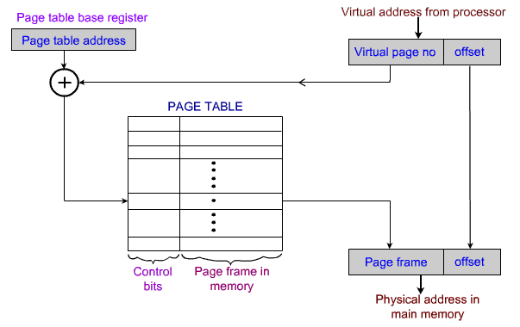

9.Difference between swap in/out and page in/out
Page in and Page Out:
1. When pages are written to disk, the event is called a page-out, and when pages are returned to physical memory, the event is called a page-in.
2. A page fault occurs when the kernel needs a page, finds it doesn't exist in physical memory because it has been paged-out, and re-reads it in from disk.
3. Page-ins are common, normal and are not a cause for concern. For example, when an application first starts up, its executable image and data are paged-in. This is normal behavior.
4. Page-outs, however, can be a sign of trouble. When the kernel detects that memory is running low, it attempts to free up memory by paging out. Though this may happen briefly from time to time, if page-outs are plentiful and constant, the kernel can reach a point where it's actually spending more time managing paging activity than running the applications, and system performance suffers. This woeful state is referred to as thrashing.
Swap in and Swap out:
1. A process must be in physical memory for execution. A process can be swapped temporarily out of physical memory to a backing store and then brought back into memory for continued execution.
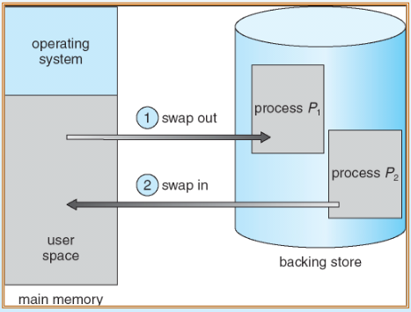

2. This applies specifically to multitasking environments where multiple processes are to be executed at the same time, and hence a cpu scheduler is implemented to decide which process to swap to the backing store.

10.Explain about kernel memory allocation and buddy system??

Buddy system:
The buddy memory allocation technique is a memory allocation algorithm that divides memory into partitions to try to satisfy a memory request as suitably as possible. This system makes use of splitting memory into halves to try to give a best-fit.system memory management attempts to be fast at allocating block of correct size and also, easy to merge adjacent holes. (We saw when you sort a free list by block size that allocations are fast, but merging is very difficult.) Exploits fact that computers deal easily with powers of two.We create several free block lists, each for a power-of-two size.
So, for example, if the minimum allocation size is 8 bytes, and the memory size is 1MB, we create a list for 8 bytes hole, a list for 16 byte holes, one for 32-bytes holes, 64, 128, 256, 512, 1K, 2K, 4K, 8K, 16K, 32K, 64K, 128K, 256K, 512K and one list for 1MB holes. All the lists are initially empty, except for the 1MB list, which has one hole listed. All allocations are rounded up to a power of two---70K allocations rounded up to 128K, 15K allocations rounded up to 16K, etc.

Kernel memory allocation:
The kernel should allocate memory dynamically to other kernel subsystems and to user processes. The KMA (kernel memory allocation) API usually consists of two functions:
void* malloc(size_t nbytes);
void free(void* ptr);
There are various issues associated with allocation of memory.
- realloc() routine. The size of an already allocated buffer is extended using this routine.
- Allocated memory should be aligned for proper access. For most systems, long word alignment is sufficient, but some machines need alignment on an eight-byte boundary.
- Some allocation systems require the size of the released buffer supplied as part of free. This allows partial freeing.
11.What is meant by thrashing?

Thrashing is a state in which our CPU perform 'productive' work less and 'swapping' more. CPU is busy in swapping pages, so much that it can not respond to user program as much as required.
Why it occurs : In our system, Thrashing occurs when there are too much pages in our memory, and each page refers to another page. The real memory shortens in capacity to have all the pages in it, so it uses 'virtual memory'. When each page in execution demands that page that is not currently in real memory (RAM) it place some pages on virtual memory and adjust the required page on RAM. If CPU is so much busy in doing this task, thrashing occurs.
To resolve thrashing you can do any of the suggestions below :
- Increase the amount of RAM in the computer.
- Decrease the number of programs being run on the computer.
- Adjust the size of the swap file.
Thrashing in computing is an issue caused when virtual memory is in use. It occurs when the virtual memory of a computer is rapidly exchanging data for data on hard disk, to the exclusion of most application-level processing. As the main memory gets filled, additional pages need to be swapped in and out of virtual memory. The swapping causes a very high rate of hard disk access. Thrashing can continue for a long duration until the underlying issue is addressed. Thrashing can potentially result in total collapse of the hard drive of the computer.Thrashing is also known as disk thrashing.

12. What do you understand by from /proc/slabinfo and slabtop commands??

/proc/slabinfo
This file gives full information about memory usage on the slab level. Linux kernels greater than version 2.2 use slab pools to manage memory above the page level. Commonly used objects have their own slab pools.
Instead of parsing the highly verbose /proc/slabinfo file manually, the /usr/bin/slabtop program displays kernel slab cache information in real time. This program allows for custom configurations, including column sorting and screen refreshing.
A sample screen shot of /usr/bin/slabtop usually looks like the following example:
Active / Total Objects (% used) : 133629 / 147300 (90.7%)
Active / Total Slabs (% used) : 11492 / 11493 (100.0%)
Active / Total Caches (% used) : 77 / 121 (63.6%)
Active / Total Size (% used) : 41739.83K / 44081.89K (94.7%)
Minimum / Average / Maximum Object : 0.01K / 0.30K / 128.00K
OBJS ACTIVE USE OBJ SIZE SLABS OBJ/SLAB CACHE SIZE NAME
44814 43159 96% 0.62K 7469 6 29876K ext3_inode_cache
36900 34614 93% 0.05K 492 75 1968K buffer_head
35213 33124 94% 0.16K 1531 23 6124K dentry_cache
7364 6463 87% 0.27K 526 14 2104K radix_tree_node
2585 1781 68% 0.08K 55 47 220K vm_area_struct
2263 2116 93% 0.12K 73 31 292K size-128
1904 1125 59% 0.03K 16 119 64K size-32
1666 768 46% 0.03K 14 119 56K anon_vma
1512 1482 98% 0.44K 168 9 672K inode_cache
1464 1040 71% 0.06K 24 61 96K size-64
1320 820 62% 0.19K 66 20 264K filp
678 587 86% 0.02K 3 226 12K dm_io
678 587 86% 0.02K 3 226 12K dm_tio
576 574 99% 0.47K 72 8 288K proc_inode_cache
528 514 97% 0.50K 66 8 264K size-512
492 372 75% 0.09K 12 41 48K bio
465 314 67% 0.25K 31 15 124K size-256
452 331 73% 0.02K 2 226 8K biovec-1
420 420 100% 0.19K 21 20 84K skbuff_head_cache
305 256 83% 0.06K 5 61 20K biovec-4
290 4 1% 0.01K 1 290 4K revoke_table
264 264 100% 4.00K 264 1 1056K size-4096
260 256 98% 0.19K 13 20 52K biovec-16
260 256 98% 0.75K 52 5 208K biovec-64
Some of the more commonly used statistics in /proc/slabinfo that are included into /usr/bin/slabtop include:
- OBJS — The total number of objects (memory blocks), including those in use (allocated), and some spares not in use.
- ACTIVE — The number of objects (memory blocks) that are in use (allocated).
- USE — Percentage of total objects that are active. ((ACTIVE/OBJS)(100))
- OBJ SIZE — The size of the objects.
- SLABS — The total number of slabs.
- OBJ/SLAB — The number of objects that fit into a slab.
- CACHE SIZE — The cache size of the slab.
- NAME — The name of the slab.

13.Write program to get resource limits using getrlimit () system call and analyze the resource limits. Check with all resource limits available

#include<stdio.h>
#include<stdlib.h>
extern int etext,edata,end;
int main[]{
printf(“Addr etext:%p\t”,&etext);
printf(“Addr edata:%p\t”,&edata);
printf(“addr end:5p\n”,&end);

cahr *s1=”hello”;
static int v1=1;
static int v2;
char s2[]=”hello”;
int *dynmem=malloc(4);

printf(“initialized data segment:%p\n”,s1);
printf(“initialized data segment:%p\n”,&v1);
printf(“uninitailized data segment :%p\n”,&v1);
printf(“stack area%p\n”,s2);
printf(“DMA%p\n”,dynmeme);
return 0;
}

14. What are the differences between kmalloc() and vmalloc() functions?

The kmalloc() & vmalloc() functions are a simple interface for obtaining kernel memory in byte-sized chunks.
- The kmalloc() function guarantees that the pages are physically contiguous (and virtually contiguous).
- The vmalloc() function works in a similar fashion to kmalloc(), except it allocates memory that is only virtually contiguous and not necessarily physically contiguous.
In order to allocate memory from kernel various types of API(application programming interfaces) are used.Two such API’s are Kmalloc() and Vmalloc().
SYNTAX:
void * kmalloc(size_t size , int flags);
void * vmalloc(unsigned long size);
Kmalloc() is use to allocate memory requested from the kernel.The memory allocated is returned by the API and it is physically as well virtually contiguous.Generally we need this physically contiguous memory when we have to implement some driver which will be used to interface some hardware or device.In kmalloc we can define the size,how much memory is needed and also we can give flags as GFP_ATOMIC and GFP_KERNEL.GFP_ATOMIC means get free pages from kernel in atomic fashion means the allocation will never sleep in between and the priority is also highest.This is generally used in interrupt handlers,and in those situation where sleep is not permitted as in the case with spinlocks.Another flag is GFP_KERNEL means get free pages from kernel,here sleep is allowed and it is normal allocation.The major disadvantage of kmalloc is that in certain cases when not enough physical memory is present,the API will return error usually NULL is returned and wastage of memory is there.There are other flags also GFP_WAIT,GFP_MASK depending on various features and requirements.The defintion of kmalloc is usually found in <slab.h> header file.
Vmalloc() is used to allocate memory from the kernel.The memory allocated is virtually contiguous but not physically contiguous.This API works in the similar manner as the user level malloc() works.It means vmalloc ensures memory is allocated from vitual address space.In vmalloc there is no option to define flag.We can give the amount of size we required in the argument.The user will not be able to distinguish the difference in memory allocated by vmalloc and kmalloc since it will be virtually contiguous but in real manner at the backend that memory will be in chunks /blocks.Every page table of the block will be having details of the another page table linked to it.If not enough memory is available then NULL will be returned.we can find vmalloc in header file<vmalloc.h>.The major advantage of vmalloc is that if enough physical contiguous memory is not available then it will allocate memory virtually in chunks and will link that memory so it appears to be virtually contiguous.
15. Do some analysis on vmstat with options –s, -a, -f, -m (need to be su for this), -n etc (-h gives all details)

vmstat - Report virtual memory statistics

SYNOPSIS
vmstat [options] [delay [count]]

DESCRIPTION
vmstat reports information about processes, memory, paging, block IO,
traps, disks and cpu activity.

The first report produced gives averages since the last reboot. Addi‐
tional reports give information on a sampling period of length delay.
The process and memory reports are instantaneous in either case.

OPTIONS
delay The delay between updates in seconds. If no delay is specified,
only one report is printed with the average values since boot.

count Number of updates. In absence of count, when delay is defined,
default is infinite.

-a, --active
Display active and inactive memory, given a 2.5.41 kernel or
better.

-f, --forks
The -f switch displays the number of forks since boot. This
includes the fork, vfork, and clone system calls, and is equiva‐
lent to the total number of tasks created. Each process is rep‐
resented by one or more tasks, depending on thread usage. This
display does not repeat.

-m, --slabs
Displays slabinfo.

-n, --one-header
Display the header only once rather than periodically.

-s, --stats
Displays a table of various event counters and memory statis‐
tics. This display does not repeat.

-h, --help
Display help and exit.

-d, --disk
Report disk statistics (2.5.70 or above required).

-D, --disk-sum
Report some summary statistics about disk activity.

-p, --partition device
Detailed statistics about partition (2.5.70 or above required).

-S, --unit character
Switches outputs between 1000 (k), 1024 (K), 1000000 (m), or
1048576 (M) bytes. Note this does not change the swap (si/so)
or block (bi/bo) fields.

-w, --wide
Wide output mode (useful for systems with higher amount of mem‐
ory, where the default output mode suffers from unwanted column
breakage). The output is wider than 80 characters per line.

-V, --version
____________________________________________________________
Filesystem Management
1.What are different types of files available? What are generic file operations? What are I/O related system calls?
Ans: A collection of data or information that has a name, called the filename. Almost all information stored in a computer must be in a file. There are many different types of files: data files, text files , program files, directory files, and so on. ... For example, program files store programs, whereas text files store text.
The set of operations allowed on files are:
- delete
- rename
- open
- close
- read
- write
- append
- seek
- get attributes (security)
- set attributes (security)
There are 5 basic system calls that Unix provides for file I/O.
1. open
2. close
3. read
4. write
5. lseek
2.How do you create special files like named pipes and device files?
Ans : The system call mknod creates special files in the following sequence.
- kernel assigns new inode,
- sets the file type to indicate that the file is a pipe, directory or special file,
- If it is a device file, it makes the other entries like major, minor device numbers.
For example:
If the device is a disk, major device number refers to the disk controller and minor device number is the disk.

3.What do you understand by VFS? Not simple abbreviation, provide the basic understanding.
Ans : In Linux, all files are accessed through the Virtual Filesystem Switch, or VFS. This is a layer of code which implements generic filesystem actions and vectors requests to the correct specific code to handle the request. Two main types of code modules take advantage of the VFS services, device drivers and filesystems.

4.What do you understand by VNODE? How it is different from inode?
Ans : A vnode is an in-memory structure that abstracts much of what an inode is (an inode can be one of its data fields) but also captures things like operations on files, locks, etc.
The inode is a data structure in a Unix-style file system that describes a filesystem object such as a file or a directory. Each inode stores the attributes and disk block location(s) of the object's data. ... A directory contains an entry for itself, its parent, and each of its children.
5.What is meant by file system? What are the different file systems supported in Linux?
Ans : A file system is an organized collection of regular files and directories. A file system is created using the mkfs command.. Linux supports numerous file systems, but common choices for the system disk on a block device include the ext* family (ext2, ext3 and ext4), XFS, JFS, ReiserFS and btrfs.

6.what is swap partition?
Ans : The swap partition is an independent section of the hard disk used solely for swapping; no other files can reside there.
To see what swap space you have, use the command swapon -s. The output will look something like this:
Filename Type Size Used Priority
/dev/sda5 partition 859436 0 -1
Each line lists a separate swap space being used by the system. Here, the 'Type' field indicates that this swap space is a partition rather than a file, and from 'Filename' we see that it is on the disk sda5. The 'Size' is listed in kilobytes, and the 'Used' field tells us how many kilobytes of swap space has been used (in this case none). 'Priority' tells Linux which swap space to use first. One great thing about the Linux swapping subsystem is that if you mount two (or more) swap spaces (preferably on two different devices) with the same priority, Linux will interleave its swapping activity between them, which can greatly increase swapping performance.
To add an extra swap partition to your system, you first need to prepare it. Step one is to ensure that the partition is marked as a swap partition and step two is to make the swap filesystem. To check that the partition is marked for swap, run as root:
fdisk -l /dev/hdb
Replace /dev/hdb with the device of the hard disk on your system with the swap partition on it. You should see output that looks like this:
Device Boot Start End Blocks Id System
/dev/hdb1 2328 2434 859446 82 Linux swap / Solaris
If the partition isn't marked as swap you will need to alter it by running fdisk and using the 't' menu option. Be careful when working with partitions -- you don't want to delete important partitions by mistake or change the id of your system partition to swap by mistake. All data on a swap partition will be lost, so double-check every change you make. Also note that Solaris uses the same ID as Linux swap space for its partitions, so be careful not to kill your Solaris partitions by mistake.
Once a partition is marked as swap, you need to prepare it using the mkswap (make swap) command as root:
mkswap /dev/hdb1
If you see no errors, your swap space is ready to use. To activate it immediately, type:
swapon /dev/hdb1
You can verify that it is being used by running swapon -s. To mount the swap space automatically at boot time, you must add an entry to the /etc/fstab file, which contains a list of filesystems and swap spaces that need to be mounted at boot up.

7.What is use of the commands df–T, mount, file, fsck? Also what is the purpose of /etc/fstab?
Ans :
df -T:The -T option in the df command displays the file system type.
Mount:An existing directory on which to mount the file system.
file: As root, use the file command ,You need to pass the individual device name to the file command.
Fsck: This will display the file system type of a given device.
/etc/fstab: If a particular mount point is configured to be mounted automatically during system startup, you can identify its file system type by looking at the /etc/fstab file.

8.The file system contains boot block, super block, inode table and data blocks. Explain this in more detail?
Ans : Overview The structure of a simple Unix file system can generally be seperated into four parts, the boot block, the super block, the inode list and the data blocks. ... The inode list (table) is a list of inodes that are used to track and maintain information about each file created on the filesystem.
A superblock is a record of the characteristics of a filesystem, including its size, the block size, the empty and the filled blocks and their respective counts, the size and location of the inode tables, the disk block map and usage information, and the size of the block groups.
Each filesystem contains: 1. a boot block located in the first few sectors of a file system. The boot block contains the initial bootstrap program used to load the operating system. Typically, the first sector contains a bootstrap program that reads in a larger bootstrap program from the next few sectors, and so forth.

The inode is a data structure in a Unix-style file system that describes a filesystem object such as a file or a directory. Each inode stores the attributes and disk block location(s) of the object's data.

9.Assuming total 15 blocks out of which 12 are direct and 3 are indirect (single, double, triple), block size is 4k, Can you calculate how much maximum size of file you can store?
Ans : 12 direct blocks
1 single block
1 double block
1 triple block
assuming 32 bit addresses,we have 4k per block,
4k/4=1024bytes
single : 1024*1k=1MB
double: 1024 * 1024*1k=1Gb
triple : 1024*1024*1024*1k=1TB
Total size :1TB

10.Explain about ext2, ext3 and ext4 file systems using in Linux?
Ans : Ext2
- Ext2 stands for second extended file system.
- It was introduced in 1993. Developed by Rémy Card.
- This was developed to overcome the limitation of the original ext file system.
- Ext2 does not have journaling feature.
- On flash drives, usb drives, ext2 is recommended, as it doesn’t need to do the over head of journaling.
- Maximum individual file size can be from 16 GB to 2 TB
- Overall ext2 file system size can be from 2 TB to 32 TB
Ext3
- Ext3 stands for third extended file system.
- It was introduced in 2001. Developed by Stephen Tweedie.
- Starting from Linux Kernel 2.4.15 ext3 was available.
- The main benefit of ext3 is that it allows journaling.
- Journaling has a dedicated area in the file system, where all the changes are tracked. When the system crashes, the possibility of file system corruption is less because of journaling.
- Maximum individual file size can be from 16 GB to 2 TB
- Overall ext3 file system size can be from 2 TB to 32 TB
- There are three types of journaling available in ext3 file system.
  - Journal – Metadata and content are saved in the journal.
  - Ordered – Only metadata is saved in the journal. Metadata are journaled only after writing the content to disk. This is the default.
  - Writeback – Only metadata is saved in the journal. Metadata might be journaled either before or after the content is written to the disk.
- You can convert a ext2 file system to ext3 file system directly (without backup/restore).
Ext4
- Ext4 stands for fourth extended file system.
- It was introduced in 2008.
- Starting from Linux Kernel 2.6.19 ext4 was available.
- Supports huge individual file size and overall file system size.
- Maximum individual file size can be from 16 GB to 16 TB
- Overall maximum ext4 file system size is 1 EB (exabyte). 1 EB = 1024 PB (petabyte). 1 PB = 1024 TB (terabyte).
- Directory can contain a maximum of 64,000 subdirectories (as opposed to 32,000 in ext3)
- You can also mount an existing ext3 fs as ext4 fs (without having to upgrade it).
- Several other new features are introduced in ext4: multiblock allocation, delayed allocation, journal checksum. fast fsck, etc. All you need to know is that these new features have improved the performance and reliability of the filesystem when compared to ext3.
- In ext4, you also have the option of turning the journaling feature “off”.
11.What is the use of /etc/mtabfile and sysctl command?

Ans : The /etc/mtab file is the list of mounted file systems it is maintained by the mount and unmount programs. It's format is similar to the fstab file The columns arw
- device the device or remote filesystem that is mounted.
- mountpoint the place in the filesystem the device was mounted.
- filesystemtype the type of filesystem mounted.
- options the mount options for the filesystem
- dump used by dump to decide if the filesystem needs dumping.
- fsckorder used by fsck to detrmine the fsck pass to use.
____________________________________________________________
Process Sub-System Management

1. What are the process states available in this process management sub-system?

A program in the execution is called a Process. Process is not the same as program. A process is more than a program code. A process is an 'active' entity as opposed to program which is considered to be a 'passive' entity. Attributes held by process include hardware state, memory, CPU etc.
Process memory is divided into four sections for efficient working :
- The text section is made up of the compiled program code, read in from non-volatile storage when the program is launched.
- The data section is made up the global and static variables, allocated and initialized prior to executing the main.
- The heap is used for the dynamic memory allocation, and is managed via calls to new, delete, malloc, free, etc.
- The stack is used for local variables. Space on the stack is reserved for local variables when they are declared.
PROCESS STATEProcesses can be any of the following states :
- New - The process is in the stage of being created.
- Ready - The process has all the resources available that it needs to run, but the CPU is not currently working on this process's instructions.
- Running - The CPU is working on this process's instructions.
- Waiting - The process cannot run at the moment, because it is waiting for some resource to become available or for some event to occur.
- Terminated - The process has completed.
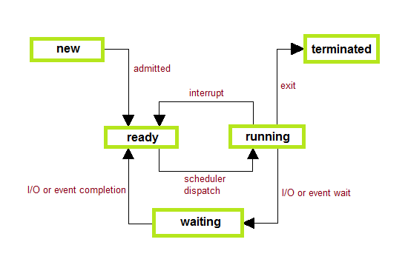

PROCESS CONTROL BLOCK
There is a Process Control Block for each process, enclosing all the information about the process. It is a data structure, which contains the following :
- Process State - It can be running, waiting etc.
- Process ID and parent process ID.
- CPU registers and Program Counter. Program Counter holds the address of the next instruction to be executed for that process.
- CPU Scheduling information - Such as priority information and pointers to scheduling queues.
- Memory Management information - Eg. page tables or segment tables.
- Accounting information - user and kernel CPU time consumed, account numbers, limits, etc.

2) What is the first process in the Kernel? What is the purpose of this process?
Ans:
The kernel at least has one runnable process, which is known as the idle task, swapper, init_task and sched. They are different names of the same process whose pid is 0. This init_task is a global variable of kernel, so it have a fixed address, you can see it from System.map by command grep 'D init_task' /boot/System.map-*. The address wouldn't change unless you recompile the kernel.
The program init whose pid is 1, spawned by init_task(pid 0). In Ubuntu, The program init is the Upstart process management daemon, while in other systems, it could be systemd. The address of init changed every time while system rebooting.
So, process 0 run first, then spawn process 1.
3. What are different types of OS scheduling algorithms available?
Ans:

Scheduling Algorithms
We'll discuss four major scheduling algorithms here which are following :
- First Come First Serve(FCFS) Scheduling
- Shortest-Job-First(SJF) Scheduling
- Priority Scheduling
- Round Robin(RR) Scheduling
- Multilevel Queue Scheduling

i.First Come First Serve(FCFS) Scheduling
Jobs are executed on first come, first serve basis.
- Jobs are executed on first come, first serve basis.
- Easy to understand and implement.
- Poor in performance as average wait time is high.
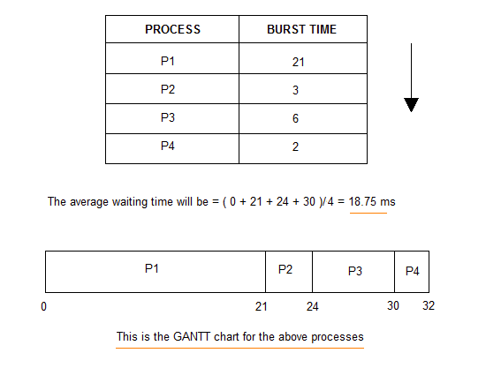

ii.Shortest-Job-First(SJF) Scheduling
- Actual time taken by the process is already known to processor.
- Impossible to implement.
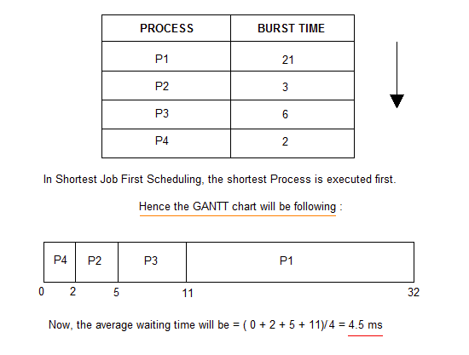
- Best approach to minimize waiting time.
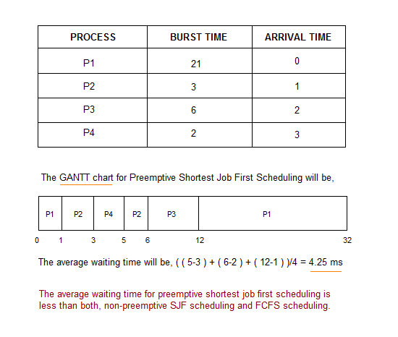
In Preemptive Shortest Job First Scheduling, jobs are put into ready queue as they arrive, but as a process with short burst time arrives, the existing process is preemptied.

iii.Priority Scheduling
- Process with highest priority is executed first and so on.
- Processes with same priority are executed in FCFS manner.
- Priority can be decided based on memory requirements, time requirements or any other resource requirement.
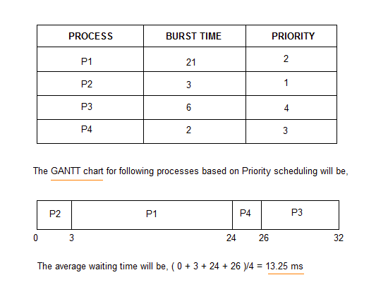
- Priority is assigned for each process.
iv.Round Robin(RR) Scheduling
- A fixed time is allotted to each process, called quantum, for execution.
- Once a process is executed for given time period that process is preemptied and other process executes for given time period.
- Context switching is used to save states of preemptied processes.
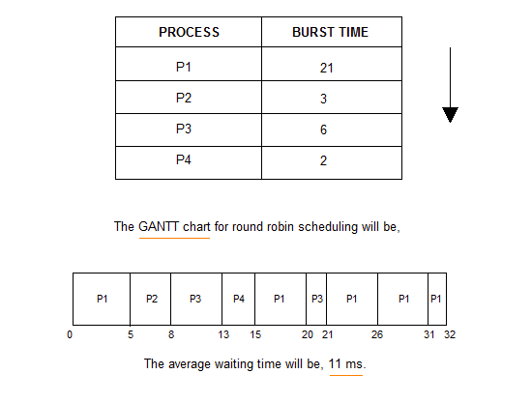
v.Multilevel Queue Scheduling

- Multiple queues are maintained for processes.
- Each queue can have its own scheduling algorithms.
- Priorities are assigned to each queue.
4. What is process kernel stack and process user stack? What is the size of each and how they are allocated?
Ans: kernel system every user process has 2 stacks , a user stack and a dedicated kernel stack for the process. User stacks resides in the user address space(First 3GB in 32-bit x86 arch.) and kernel stack resides in the kernel address space ( 3GB-4GB in 32bit-x86) of the process.
When a user process needs to execute some privileged instruction (A system call) it traps to kernel mode and kernel executes the it on behalf of the user process. This execution takes place on the processes' kernel stack.
5. Why do we need separate kernel stack for each process?
Ans: Separate kernel stacks are not really mandated. Each architecture is free to do whatever it wants. If there was no per-emption during a system call, then a single kernel stack might make sense.
However, *nix has processes and each process can make a system call. However, Linux allows one task to be pre-empted during a write(), etc and another task to schedule. The kernel stack is a snapshot of the context of kernel work that is being performed for each process.
Also, the per-process kernel stacks come with little overhead. A thread_info or some mechanism to get the process information from assembler is needed. This is at least a page allocation. By placing the kernel mode stack in the same location, a simple mask can get the thread_info from assembler. So, we already need the per-process variable and allocation.

6. List the system calls used for process management.
Ans:
System calls used for Process management:
• Fork () - Used to create a new process
• Exec() - Execute a new program
• Wait() - wait until the process finishes execution
• Exit() - Exit from the process
• Getpid() - get the unique process id of the process
• Getppid() - get the parent process unique id
• Nice() - to bias the existing property of process

7. What happens when you execute a program and when you execute a command?
Ans: The function _start gets invoked, as the ELF header specifies it as the entry point for the executable
- _start calls __libc_start_main in glibc (through the PLT) passing the following information to it
- the address of the actual main function
- the argc address
- the argv address
- the address of the _init routine
- the address of the _fini routine
- a function pointer for the atexit() registration
- the highest stack address available
- _init gets called
- calls call_gmon_start to initialize gmon profiling. not really related to execution.
- calls frame_dummy, which wraps __register_frame_info(eh_frame section address, bss section address) (FIXME: what does this function do? initializes global vars from the BSS section apparently)
- calls __do_global_ctors_aux, whose role is to call all the global constructors listed in the .ctors section.
- main gets called
- main ends
- _fini gets called, which in turns calls __do_global_dtors_aux to run all destructors as specified in the .dtors section.
- the program exits.
when we type a command such as ls on interactive shell,
- Shell interpretes the command.
- Shell creates a child process and excecutes the command on the child process.
- Shell waits for the child process's completion.

8. What do you understand by short term scheduler and long term scheduler?

Long Term Scheduler :
It is also called a job scheduler. A long-term scheduler determines which programs are admitted to the system for processing. It selects processes from the queue and loads them into memory for execution. Process loads into the memory for CPU scheduling.

Short Term Scheduler :
It is also called as CPU scheduler. Its main objective is to increase system performance in accordance with the chosen set of criteria. It is the change of ready state to running state of the process. CPU scheduler selects a process among the processes that are ready to execute and allocates CPU to one of them.
Short-term schedulers, also known as dispatchers, make the decision of which process to execute next. Short-term schedulers are faster than long-term schedulers.

9. What do you understand by PROC file system? Also, what are the commands related to
process management system.

Inside the /proc directory, you’ll see two types of content — numbered directories, and system information files.
/proc is not a real file system, it is a virtual file system. For example, if you do ls -l /proc/stat, you’ll notice that it has a size of 0 bytes, but if you do “cat /proc/stat”, you’ll see some content inside the file.
Several Linux commands access the information from /proc, and displays in a certain format.

i). /proc Directories with names as numbers
Do a ls -l /proc, and you’ll see lot of directories with just numbers. These numbers represents the process ids, the files inside this numbered directory corresponds to the process with that particular PID.
Following are the important files located under each numbered directory (for each process):
- cmdline – command line of the command.
- environ – environment variables.
- fd – Contains the file descriptors which is linked to the appropriate files.
- limits – Contains the information about the specific limits to the process.
- mounts – mount related information
Following are the important links under each numbered directory (for each process):
- cwd – Link to current working directory of the process.
- exe – Link to executable of the process.
- root – Link to the root directory of the process.

ii). /proc Files about the system information
Following are some files which are available under /proc, that contains system information such as cpuinfo, meminfo, loadavg.
- /proc/cpuinfo – information about CPU,
- /proc/meminfo – information about memory,
- /proc/loadvg – load average,
- /proc/partitions – partition related information,
- /proc/version – linux version
Some Linux commands read the information from this /proc files and displays it. For example, free command, reads the memory information from /proc/meminfo file, formats it, and displays it.
To learn more about the individual /proc files, do “man 5 FILENAME”.
- /proc/cmdline – Kernel command line
- /proc/cpuinfo – Information about the processors.
- /proc/devices – List of device drivers configured into the currently running kernel.
- /proc/dma – Shows which DMA channels are being used at the moment.
- /proc/fb – Frame Buffer devices.
- /proc/filesystems – File systems supported by the kernel.
- /proc/interrupts – Number of interrupts per IRQ on architecture.
- /proc/iomem – This file shows the current map of the system’s memory for its various devices
- /proc/ioports – provides a list of currently registered port regions used for input or output communication with a device
- /proc/loadavg – Contains load average of the system
The first three columns measure CPU utilization of the last 1, 5, and 10 minute periods.
The fourth column shows the number of currently running processes and the total number of processes.
The last column displays the last process ID used.
- /proc/locks – Displays the files currently locked by the kernel
Sample line:
1: POSIX ADVISORY WRITE 14375 08:03:114727 0 EOF
- /proc/meminfo – Current utilization of primary memory on the system
- /proc/misc – This file lists miscellaneous drivers registered on the miscellaneous major device, which is number 10
- /proc/modules – Displays a list of all modules that have been loaded by the system
- /proc/mounts – This file provides a quick list of all mounts in use by the system
- /proc/partitions – Very detailed information on the various partitions currently available to the system
- /proc/pci – Full listing of every PCI device on your system
- /proc/stat – Keeps track of a variety of different statistics about the system since it was last restarted
- /proc/swap – Measures swap space and its utilization
- /proc/uptime – Contains information about uptime of the system
- /proc/version – Version of the Linux kernel, gcc, name of the Linux flavor installed.
10. What do you understand by various processes zombie, orphan and daemon processes?What are the usual daemon (Disk and Execution Monitor) processes in the system?
Ans:
Orphan Process
An orphan process is a computer process whose parent process has finished or terminated, though it remains running itself.
In a Unix-like operating system any orphaned process will be immediately adopted by the special init system process. This operation is called re-parenting and occurs automatically. Even though technically the process has the init process as its parent, it is still called an orphan process since the process that originally created it no longer exists.
A process can be orphaned unintentionally, such as when the parent process terminates or crashes. The process group mechanism in most Unix-like operation systems can be used to help protect against accidental orphaning, where in coordination with the user’s shell will try to terminate all the child processes with the SIGHUP process signal, rather than letting them continue to run as orphans.
A process may also be intentionally orphaned so that it becomes detached from the user’s session and left running in the background; usually to allow a long-running job to complete without further user attention, or to start an indefinitely running service. Under Unix, the latter kinds of processes are typically called daemon processes. The Unix nohup command is one means to accomplish this.

Daemon Process
In Unix and other multitasking computer operating systems, a daemon is a computer program that runs as a background process, rather than being under the direct control of an interactive user. Typically daemon names end with the letter d: for example, syslogd is the daemon that implements the system logging facility and sshd is a daemon that services incoming SSH connections.
In a Unix environment, the parent process of a daemon is often, but not always, the init process. A daemon is usually created by a process forking a child process and then immediately exiting, thus causing init to adopt the child process. In addition, a daemon or the operating system typically must perform other operations, such as dissociating the process from any controlling terminal (tty). Such procedures are often implemented in various convenience routines such as daemon(3) in Unix.
Daemon process is a process orphaned intentionally.

Zombie Process
On Unix and Unix-like computer operating systems, a zombie process or defunct process is a process that has completed execution but still has an entry in the process table. This entry is still needed to allow the parent process to read its child’s exit status. The term zombie process derives from the common definition of zombie — an undead person. In the term’s metaphor, the child process has “died” but has not yet been “reaped”. Also, unlike normal processes, the kill command has no effect on a zombie process.
When a process ends, all of the memory and resources associated with it are deallocated so they can be used by other processes. However, the process’s entry in the process table remains. The parent can read the child’s exit status by executing the wait system call, whereupon the zombie is removed. The wait call may be executed in sequential code, but it is commonly executed in a handler for the SIGCHLD signal, which the parent receives whenever a child has died.
After the zombie is removed, its process identifier (PID) and entry in the process table can then be reused. However, if a parent fails to call wait, the zombie will be left in the process table. In some situations this may be desirable, for example if the parent creates another child process it ensures that it will not be allocated the same PID. On modern UNIX-like systems (that comply with SUSv3 specification in this respect), the following special case applies: if the parent explicitly ignores SIGCHLD by setting its handler to SIG_IGN (rather than simply ignoring the signal by default) or has the SA_NOCLDWAIT flag set, all child exit status information will be discarded and no zombie processes will be left
A zombie process is not the same as an orphan process. An orphan process is a process that is still executing, but whose parent has died. They do not become zombie processes; instead, they are adopted by init (process ID 1), which waits on its children.
A disk and execution monitor (daemon) is a background process run in computer multitasking operating systems, usually at bootstrap time, to perform administrative changes or monitor services.
Common daemon processes include email handlers, print spoolers and other programs that perform OS administrative tasks. Daemons also perform specified operations at predefined times in response to events.

11. What do you understand by terms context switching, pre-emptive scheduling and non-preemptive scheduling?
Ans:
Context Switch Definition. A context switch (also sometimes referred to as a process switch or a task switch) is the switching of the CPU (central processing unit) from one process or thread to another. A process (also sometimes referred to as a task) is an executing (i.e., running) instance of a program

Preemptive scheduling: The preemptive scheduling is prioritized. The highest priority process should always be the process that is currently utilized.Preemptive algorithms are driven by the notion of prioritized computation. The process with the highest priority should always be the one currently using the processor. If a process is currently using the processor and a new process with a higher priority enters, the ready list, the process on the processor should be removed and returned to the ready list until it is once again the highest-priority process in the system
Non-Preemptive scheduling: When a process enters the state of running, the state of that process is not deleted from the scheduler until it finishes its service time.Non-preemptive algorithms are designed so that once a process enters the running state(is allowed a process), it is not removed from the processor until it has completed its service time ( or it explicitly yields the processor). context_switch() is called only when the process terminates or blocks
12. What is time slice? Explain PCB?
Ans: Time slice:
A short interval of time allotted to each user or program in a multitasking or timesharing system. Time slices are typically in milliseconds.
Each process has a status associated with it. Many processes consume no CPU time until they get some sort of input. For example, a process might be waiting for a keystroke from the user. While it is waiting for the keystroke, it uses no CPU time. While it's waiting, it is ""suspended"". When the keystroke arrives, the OS changes its status. When the status of the process changes, from pending to active, for example, or from suspended to running, the information in the process control block must be used like the data in any other program to direct execution of the task-switching portion of the operating system.

________________________________________________________________________________
Device Management

1.What is the purpose of DMA (Direct Memory Access)?
Ans: DMA is a feature of modern computers that allow certain hardware subsystems within the computer to access system memory for reading or writing independently of the CPU. Without DMA, the CPU is fully occupied for the entire duration of read or write operation and is unavailable to perform other tasks. With the help of DMA, the CPU would initiate the transfer, do other operations while the transfer is in progress and receive an interrupt from the DMA controller once the operation has been done (Operating System Concepts, 2008). Many computers avoid burdening the CPU by offloading some of its work to special purpose processor called DMA controller. It consists of memory address register, a byte count register, and one or more control registers. More commonly, a single DMA controller is available for regulating transfer to multiple devices but some systems may have integrated with disk controllers.
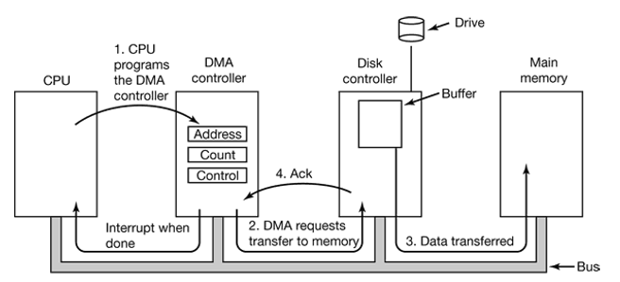
Working:
The CPU programs the DMA controller by its registers so it knows what to transfer where. It also issues a command to disk controller telling it to read data from disk to its internal buffer and verify the checksum. When valid data are in disk’s controller buffer, DMA can start.
- The DMA controller initiates the transfer by issuing a read request over the bus to the disk controller.
- Data is transferred from disk controller to memory.
- When the transfer is completed, the disk controller sends an acknowledgment signal to DMA controller. The DMA controller then increments the memory address to use and decrements the byte count. This continues till the byte count is greater than 0.
- When the transfer is complete, the DMA controller interrupts the CPU.
2.What happens when interrupt is raised by any Device? Explain interrupt handling
mechanism in Linux?
Ans: An interrupt is an unexpected hardware initiated subroutine call or jump that temporarily suspends the running of the current program.
Interrupts occur when a peripheral device asserts an interrupt input pin of the micro-processor. Provided the interrupt is permitted, it will be acknowledged by the processor at the end of the current memory cycle. The processor then services the interrupt by branching to a special service routine written to handle that particular interrupt. Upon servicing the device, the processor is then instructed to continue with what is was doing previously by use of the "return from interrupt" instruction.
Interrupts fall into two major categories, maskable and non-maskable. An interrupt may be either EDGE or LEVEL sensitive.
Interrupt handling
Here we describe interrupt handling in a scenario where the hardware does not support identifying the device that initiated the interrupt. In such cases, the possible interrupting devices need to be polled in software.
- A device asserts the interrupt signal at a hardwired interrupt level.
- The processor registers the interrupt and waits to finish the current instruction execution.
- Once the current instruction execution is completed, the processor initiates the interrupt handling by saving the current register contents on the stack.
- The processor then switches to supervisor mode and initiates an interrupt acknowledge cycle.
- No device responds to the interrupt acknowledge cycle, so the processor fetches the vector corresponding to the interrupt level.
- The address found at the vector is the address of the interrupt service routine (ISR).
- The ISR polls all the devices to find the device that caused the interrupt. This is accomplished by checking the interrupt status registers on the devices that could have triggered the interrupt.
- Once the device is located, control is transferred to the handler specific to the interrupting device.
- After the device specific ISR routine has performed its job, the ISR executes the "return from interrupt" instruction.
- Execution of the "return from interrupt" instruction results in restoring the processor state. The processor is restored back to user mode.
3.Why is interrupt vector used in OS? What is the need of device status table?
Ans:
- Device Status Table: Each entry indicates the status (e.g., busy and idle) of the
corresponding device. When the status is “busy”, the requests are
queued and processed later when the device becomes “idle”. A
device entry can have a chain of the requests for the device.
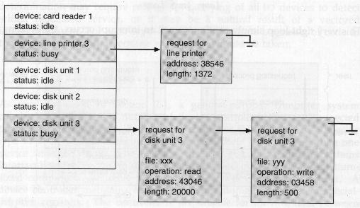

4.Explain the positioning time for a disk (seek time, latency time)
Ans: Seek time: Say you're reading some data from the (0,4). You receive instructions to read from track (2,5). The time it takes for you to move from track 0 to track 2 is seek time.
Latency: Once you reach track 2, you realize the head is above the 1st sector you'll have to wait till the disk rotates to the 5th sector so that you can start reading from (2,5). The time you wait for the sector to be accessible by your head here is known as latency.
5.Explain the terms buses, devices and drivers?
Ans:
Bus: A bus, in computing, is a set of physical connections (cables, printed circuits, etc.) which can be shared by multiple hardware components in order to communicate with one another.
The purpose of buses is to reduce the number of "pathways" needed for communication between the components, by carrying out all communications over a single data channel. This is why the metaphor of a "data highway" is sometimes used.
Devices: The term devices in computer is a physical object, which is used as I/O objects in computer.
Ex: RAM, Hard disk, WIFI etc.
Drivers: A driver is a software component that lets the operating system and a device communicate with each other. For example, suppose an application needs to read some data from a device. The application calls a function implemented by the operating system, and the operating system calls a function implemented by the driver. The driver, which was written by the same company that designed and manufactured the device, knows how to communicate with the device hardware to get the data. After the driver gets the data from the device, it returns the data to the operating system, which returns it to the application.
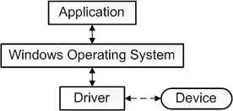

6.Analyze /dev directory and various character and block special files under /dev
Ans:
Under Linux and UNIX each and every hardware device treated as a file. A device file allows to accesses hardware devices so that end users do not need to get technical details about hardware.
In short, a device file (also called as a special file) is an interface for a device driver that appears in a file system as if it were an ordinary file. This allows software to interact with the device driver using standard input/output system calls, which simplifies many tasks.
Device file two types
There are two types of device files based upon how data written to them and read from them is processed by the operating system and hardware:
- Character special files or Character devices
- Block special files or Block devices
Understanding Character special files or Character devices
- Talks to devices in a character by character (1 byte at a time)
- Examples: Virtual terminals, terminals and serial modems etc
Understanding Block special files or Block devices
- Talks to devices 1 block at a time ( 1 block = 512 bytes to 32KB)
- Examples: Hard disk, DVD/CD ROM, and memory regions etc
All device files are stored in /dev directory. Use cd and ls command to browse the directory:
cd /dev/
ls -l
A character device is marked with a c as the first letter of the permissions strings.
$ ls -l /dev/console
A block device is marked with a b as the first letter of the permissions strings:
$ ls -l /dev/sdb1
7.What do you understand by mount points?
Ans:A mount point is a directory (typically an empty one) in the currently accessible filesystem on which an additional filesystem is mounted (i.e., logically attached).
A filesystem is a hierarchy of directories (also referred to as a directory tree) that is used to organize files on a computer system. On Linux and other Unix-like operating system, at the very top of this hierarchy is the root directory, which contains all other directories on the system, inclusive of their subdirectories, etc. A variant of this definition is the part of the entire hierarchy of directories (i.e., of the directory tree) that is located on a single partition or disk. A partition is a logically independent section of a hard disk drive (HDD).
The mount point becomes the root directory of the newly added filesystem, and that filesystem becomes accessible from that directory. Any original contents of that directory become invisible and inaccessible until the filesystem is unmounted (i.e., detached from the main filesystem).
8.Check with information from /proc file system files viz., devices, partitions,
interrupts, mounts, iomem, swaps, diskstats, softirqs, devices (under
/proc/bus/input).
Ans: /proc Files about the system information
- /proc/cpuinfo – information about CPU,
- /proc/meminfo – information about memory,
- /proc/loadvg – load average,
- /proc/partitions – partition related information,
- /proc/version – linux version
- /proc/cmdline – Kernel command line
- /proc/cpuinfo – Information about the processors.
- /proc/devices – List of device drivers configured into the currently running kernel.
- /proc/dma – Shows which DMA channels are being used at the moment.
- /proc/fb – Frame Buffer devices.
- /proc/filesystems – File systems supported by the kernel.
- /proc/interrupts – Number of interrupts per IRQ on architecture.
- /proc/iomem – This file shows the current map of the system’s memory for its various devices
- /proc/ioports – provides a list of currently registered port regions used for input or output communication with a device
- /proc/loadavg – Contains load average of the system
The first three columns measure CPU utilization of the last 1, 5, and 10 minute periods.
The fourth column shows the number of currently running processes and the total number of processes.
The last column displays the last process ID used.
- /proc/locks – Displays the files currently locked by the kernel
Sample line:
1: POSIX ADVISORY WRITE 14375 08:03:114727 0 EOF
- /proc/meminfo – Current utilization of primary memory on the system
- /proc/misc – This file lists miscellaneous drivers registered on the miscellaneous major device, which is number 10
- /proc/modules – Displays a list of all modules that have been loaded by the system
- /proc/mounts – This file provides a quick list of all mounts in use by the system
- /proc/partitions – Very detailed information on the various partitions currently available to the system
- /proc/pci – Full listing of every PCI device on your system
- /proc/stat – Keeps track of a variety of different statistics about the system since it was last restarted
- /proc/swap – Measures swap space and its utilization
- /proc/uptime – Contains information about uptime of the system
- /proc/version – Version of the Linux kernel, gcc, name of the Linux flavor installed.
9.Work on I/O control (ioctl()) in Linux
Ans: Input-output control (ioctl, in short) is a common operation or system call available with most of the driver categories. It is a “one bill fits all” kind of system call. If there is no other system call, which meets the requirement, then definitely ioctl() is the one to use. Practical examples include volume control for an audio device, display configuration for a video device, reading device registers, … – basically anything to do with any device input / output, or for that matter any device specific operations. In fact, it is even more versatile – need not be tied to any device specific things but any kind of operation. An example includes debugging a driver, say by querying of driver data structures.
The following had been its prototype in Linux kernel, for quite some time:
int ioctl(struct inode *i, struct file *f, unsigned int cmd, unsigned long arg);

Though, recently from kernel 2.6.35, it has changed to the following:
long ioctl(struct file *f, unsigned int cmd, unsigned long arg);

Network Management

1.Sevan Layers of Open System Interconnection(OSI) Model
Ans: If network communications need to happen with out any trouble, many problems must be solved. In 1977 the International Standards Organization (ISO) proposed the Open Systems Interconnection (OSI) network model. The Open Systems Interconnection (OSI) model breaks down the problems involved in moving data from one computer to another computer. Open Systems Interconnection (OSI) model categorizes these hundreds of problems to Seven Layers. A layer in Open Systems Interconnection (OSI) model is a portion that is used to categorize specific problems.
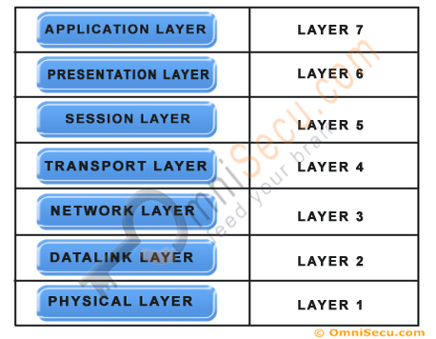
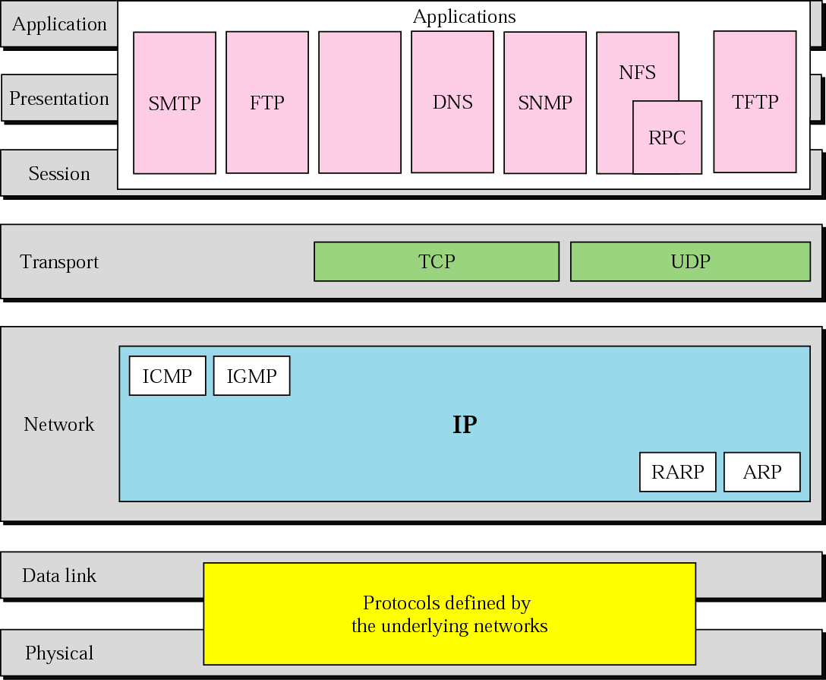

- Layer 1. Physical Layer
The first layer of the seven layers of Open Systems Interconnection (OSI) network model is called the Physical layer. Physical circuits are created on the physical layer of Open Systems Interconnection (OSI) model. Physical layers describe the electrical or optical signals used for communication. Physical layer of the Open Systems Interconnection (OSI) model is only concerned with the physical characteristics of electrical or optical signaling techniques which includes the voltage of the electrical current used to transport the signal, the media type (Twisted Pair, Coaxial Cable, Optical Fiber etc), impedance characteristics, physical shape of the connector, Synchronization etc. The Physical Layer is limited to the processes needed to place the communication signals over the media, and to receive signals coming from that media. The lower boundary of the physical layer of the Open Systems Interconnection (OSI) model is the physical connector attached to the transmission media. Physical layer of the Open Systems Interconnection (OSI) model does not include the transmission media. Transmission media stays outside the scope of the Physical Layer and are also referred to as Layer 0 of the Open Systems Interconnection (OSI) Model.

Layer 2. Datalink Layer
The second layer of the seven layers of Open Systems Interconnection (OSI) network model is called the Datalink layer. The Data Link layer resides above the Physical layer and below the Network layer. Datalink layer is responsible for providing end-to-end validity of the data being transmitted. The Data Link Layer is logically divided into two sublayers, The Media Access Control (MAC) Sublayer and the Logical Link Control (LLC) Sublayer.
Media Access Control (MAC) Sublayer determines the physical addressing of the hosts. The MAC sub-layer maintains MAC addresses (physical device addresses) for communicating with other devices on the network. MAC addresses are burned into the network cards and constitute the low-level address used to determine the source and destination of network traffic. MAC Addresses are also known as Physical addresses, Layer 2 addresses, or Hardware addresses.
The Logical Link Control sublayer is responsible for synchronizing frames, error checking, and flow control.

Layer 3. Network Layer
The third layer of the seven layers of Open Systems Interconnection (OSI) network model is the Network layer. The Network layer of the OSI model is responsible for managing logical addressing information in the packets and the delivery of those packets to the correct destination. Routers, which are special computers used to build the network, direct the data packet generated by Network Layer using information stored in a table known as routing table. The routing table is a list of available destinations that are stored in memory on the routers. The network layer is responsible for working with logical addresses. The logical addresses are used to uniquely identify a computer on the network, but at the same time identify the network that system resides on. The logical address is used by network layer protocols to deliver the packets to the correct network. The Logical addressing system used in Network Layer is known as IP address.
IP addresses are also known as Logical addresses or Layer 3 addresses.

Layer 4. Transport Layer
The fourth layer of the seven layers of Open Systems Interconnection (OSI) network mode is the Transport layer. The Transport layer handles transport functions such as reliable or unreliable delivery of the data to the destination. On the sending computer, the transport layer is responsible for breaking the data into smaller packets, so that if any packet is lost during transmission, the missing packets will be sent again. Missing packets are determined by acknowledgments (ACKs) from the remote device, when the remote device receives the packets. At the receiving system, the transport layer will be responsible for opening all of the packets and reconstructing the original message.
Another function of the transport layer is TCP segment sequencing. Sequencing is a connection-oriented service that takes TCP segments that are received out of order and place them in the right order.
The transport layer also enables the option of specifying a "service address" for the services or application on the source and the destination computer to specify what application the request came from and what application the request is going to.
Many network applications can run on a computer simultaneously and there should be some mechanism to identify which application should receive the incoming data. To make this work correctly, incoming data from different applications are multiplexed at the Transport layer and sent to the bottom layers. On the other side of the communication, the data received from the bottom layers are de-multiplexed at the Transport layer and delivered to the correct application. This is achieved by using "Port Numbers".
The protocols operating at the Transport Layer, TCP (Transmission Control Protocol) and UDP (User Datagram Protocol) uses a mechanism known as "Port Number" to enable multiplexing and de-multiplexing. Port numbers identify the originating network application on the source computer and destination network application on the receiving computer.

Layer 5. Session Layer
The position of Session Layer of the Seven Layered Open Systems Interconnection (OSI) model is between Transport Layer and the Presentation Layer. Session layer is the fifth layer of seven layered Open Systems Interconnection (OSI) Model. The session layer is responsible for establishing, managing, and terminating connections between applications at each end of the communication.
In the connection establishment phase, the service and the rules (who transmits and when, how much data can be sent at a time etc.) for communication between the two devices are proposed. The participating devices must agree on the rules. Once the rules are established, the data transfer phase begins. Connection termination occurs when the session is complete, and communication ends gracefully.
In practice, Session Layer is often combined with the Transport Layer.

Layer 6. Presentation Layer
The position of Presentation Layer in seven layered Open Systems Interconnection (OSI) model is just below the Application Layer. When the presentation layer receives data from the application layer, to be sent over the network, it makes sure that the data is in the proper format. If it is not, the presentation layer converts the data to the proper format. On the other side of communication, when the presentation layer receives network data from the session layer, it makes sure that the data is in the proper format and once again converts it if it is not.
Formatting functions at the presentation layer may include compression, encryption, and ensuring that the character code set (ASCII, Unicode, EBCDIC (Extended Binary Coded Decimal Interchange Code, which is used in IBM servers) etc) can be interpreted on the other side.
For example, if we select to compress the data from a network application that we are using, the Application Layer will pass that request to the Presentation Layer, but it will be the Presentation Layer that does the compression.

Layer 7. Application Layer
The Application Layer the seventh layer in OSI network model. Application Layer is the top-most layer of the seven layered Open Systems Interconnection (OSI) network model. Real traffic data will be often generated from the Application Layer. This may be a web request generated from HTTP protocol, a command from telnet protocol, a file download request from FTP protocol etc.
In this lesson (Seven Layers of Open Systems Interconnection (OSI) Model), you have learned what are the Seven Layers of Open Systems Interconnection (OSI) Model and the functions of these seven layers. The top-most layer of the Seven Layers of Open Systems Interconnection (OSI) Model is the Application Layer and the bottom-most layer of the Seven Layers of Open Systems Interconnection (OSI) Model is Physical Layer. Click "Next" to Continue.

2.What is TCP/IP model of networking and what is UDP/IP model of networking?
Also note the differences between them.
Ans:
TCP/IP means Transmission Control Protocol and Internet Protocol. It is the network model used in the current Internet architecture as well. Protocols are set of rules which govern every possible communication over a network. These protocols describe the movement of data between the source and destination or the internet. These protocols offer simple naming and addressing schemes.

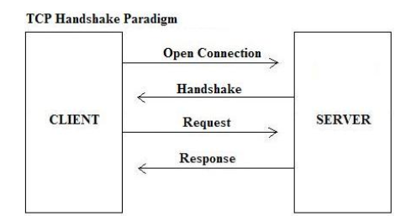

What udp/Ip model

UDP is a connectionless and unreliable transport protocol.The two ports serve to identify the end points within the source and destination machines. User Datagram Protocol is used, in place of TCP, when a reliable delivery is not required.However, UDP is never used to send important data such as web-pages, database information, etc. Streaming media such as video,audio and others use UDP because it offers speed.

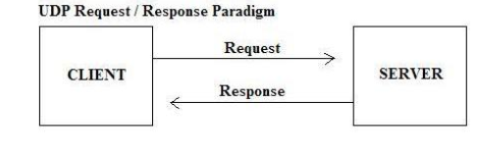

Also note the differences between them?

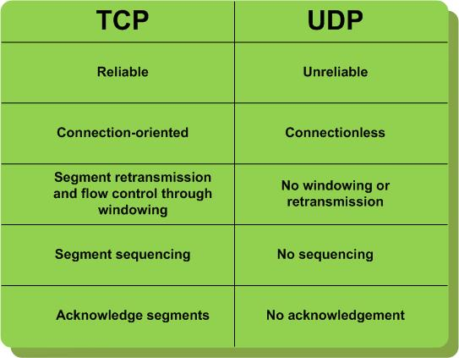

3. How OSI is different from 4 layer TCP/IP model
Ans:
OSI(Open System Interconnection) TCP/IP(Transmission Control Protocol / Internet Protocol)
1. OSI is a generic, protocol independent standard, acting as a communication gateway between the network and end user.
1. TCP/IP model is based on standard protocols around which the Internet has developed. It is a communication protocol, which allows connection of hosts over a network.
2. In OSI model the transport layer guarantees the delivery of packets.
2. In TCP/IP model the transport layer does not guarantees delivery of packets. Still the TCP/IP model is more reliable.
3. Follows vertical approach.
3. Follows horizontal approach.
4. OSI model has a separate Presentation layer and Session layer.
4. TCP/IP does not have a separate Presentation layer or Session layer.
5. OSI is a reference model around which the networks are built.
Generally it is used as a guidance tool.
5. TCP/IP model is, in a way implementation of the OSI model.
6. Network layer of OSI model provides both connection oriented and connectionless service.
6. The Network layer in TCP/IP model provides connectionless service.
7. OSI model has a problem of fitting the protocols into the model.
7. TCP/IP model does not fit any protocol
8. Protocols are hidden in OSI model and are easily replaced as the technology changes.
8. In TCP/IP replacing protocol is not easy.
9. OSI model defines services, interfaces and protocols very clearly and makes clear distinction between them. It is protocol independent.
9. In TCP/IP, services, interfaces and protocols are not clearly separated. It is also protocol dependent.
10. It has 7 layers
10. It has 4 layers

4. What are different networking protocols?
Ans:
Rules of Network Protocol include guidelines that regulate the following characteristics of a network: access method, allowed physical topologies, types of cabling, and speed of data transfer.
Types of Network Protocols

The most common network protocols are:
Ethernet
Local Talk
Token Ring
FDDI
ATM

The followings are some commonly used network symbols to draw different kinds of network protocols.
Types of Network Protocols

Ethernet:
The Ethernet protocol is by far the most widely used one. Ethernet uses an access method called CSMA/CD (Carrier Sense Multiple Access/Collision Detection). This is a system where each computer listens to the cable before sending anything through the network. If the network is clear, the computer will transmit. If some other nodes have already transmitted on the cable, the computer will wait and try again when the line is clear. Sometimes, two computers attempt to transmit at the same instant. A collision occurs when this happens. Each computer then backs off and waits a random amount of time before attempting to retransmit. With this access method, it is normal to have collisions. However, the delay caused by collisions and retransmitting is very small and does not normally effect the speed of transmission on the network.
The Ethernet protocol allows for linear bus, star, or tree topologies. Data can be transmitted over wireless access points, twisted pair, coaxial, or fiber optic cable at a speed of 10 Mbps up to 1000 Mbps.

Fast Ethernet:
To allow for an increased speed of transmission, the Ethernet protocol has developed a new standard that supports 100 Mbps. This is commonly called Fast Ethernet. Fast Ethernet requires the application of different, more expensive network concentrators/hubs and network interface cards. In addition, category 5 twisted pair or fiber optic cable is necessary. Fast Ethernet is becoming common in schools that have been recently wired.

Local Talk:
Local Talk is a network protocol that was developed by Apple Computer, Inc. for Macintosh computers. The method used by Local Talk is called CSMA/CA (Carrier Sense Multiple Access with Collision Avoidance). It is similar to CSMA/CD except that a computer signals its intent to transmit before it actually does so. Local Talk adapters and special twisted pair cable can be used to connect a series of computers through the serial port. The Macintosh operating system allows the establishment of a peer-to-peer network without the need for additional software. With the addition of the server version of AppleShare software, a client/server network can be established.

The Local Talk protocol allows for linear bus, star, or tree topologies using twisted pair cable. A primary disadvantage of Local Talk is low speed. Its speed of transmission is only 230 Kbps.

Token Ring:
The Token Ring protocol was developed by IBM in the mid-1980s. The access method used involves token-passing. In Token Ring, the computers are connected so that the signal travels around the network from one computer to another in a logical ring. A single electronic token moves around the ring from one computer to the next. If a computer does not have information to transmit, it simply passes the token on to the next workstation. If a computer wishes to transmit and receives an empty token, it attaches data to the token. The token then proceeds around the ring until it comes to the computer for which the data is meant. At this point, the data is captured by the receiving computer. The Token Ring protocol requires a star-wired ring using twisted pair or fiber optic cable. It can operate at transmission speeds of 4 Mbps or 16 Mbps. Due to the increasing popularity of Ethernet, the use of Token Ring in school environments has decreased.

FDDI:
Fiber Distributed Data Interface (FDDI) is a network protocol that is used primarily to interconnect two or more local area networks, often over large distances. The access method used by FDDI involves token-passing. FDDI uses a dual ring physical topology. Transmission normally occurs on one of the rings; however, if a break occurs, the system keeps information moving by automatically using portions of the second ring to create a new complete ring. A major advantage of FDDI is high speed. It operates over fiber optic cable at 100 Mbps.

ATM:
Asynchronous Transfer Mode (ATM) is a network protocol that transmits data at a speed of 155 Mbps and higher. ATM works by transmitting all data in small packets of a fixed size; whereas, other protocols transfer variable length packets. ATM supports a variety of media such as video, CD-quality audio, and imaging. ATM employs a star topology, which can work with fiber optic as well as twisted pair cable.
ATM is most often used to interconnect two or more local area networks. It is also frequently used by Internet Service Providers to utilize high-speed access to the Internet for their clients. As ATM technology becomes more cost-effective, it will provide another solution for constructing faster local area networks.

Gigabit Ethernet:
The most latest development in the Ethernet standard is a protocol that has a transmission speed of 1 Gbps. Gigabit Ethernet is primarily used for backbones on a network at this time. In the future, it will probably also be used for workstation and server connections. It can be used with both fiber optic cabling and copper. The 1000BaseTX, the copper cable used for Gigabit Ethernet, became the formal standard in 1999.

5.Why do we have MAC and IP addresses?
Ans:
Ip address(network address) is just use for transfering informatiom from one network to an other.travelling of information among networks uses ip addresses.
Mac addresses(physical addresses) is actually uses for distrubution of information.so, the summay is:-
1) carring of information from one network to another.
2) distrubtion of information(resources) is based upon mac address.
Example:-
Network A , Network B and Network C are three networks.all network are having 5 nodes(client).if i want to send information to node 3 for network B.
Solution:-
1) first i send infomation to network by the help of IP address of that network(Network B).Ip addresses are unique on network layer(this is the fact).
2)after that i will send infomation to node 3 of network B by the help of mac address which is unique at layer 2(DLL).

6. What are different types of topologies viz., bus, ring, star, mesh
Ans:
Types of Network Topology:
Network Topology is the schematic description of a network arrangement, connecting various nodes(sender and receiver) through lines of connection.

BUS Topology:
Bus topology is a network type in which every computer and network device is connected to single cable. When it has exactly two endpoints, then it is called Linear Bus topology.
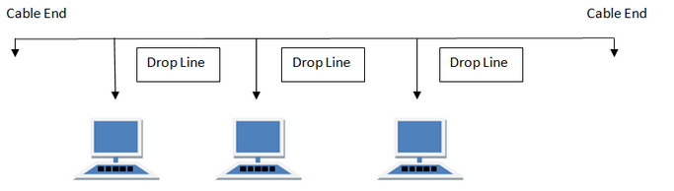

Bus topology in computer networks
Features of Bus Topology

It transmits data only in one direction.
Every device is connected to a single cable

Advantages of Bus Topology

It is cost effective.
Cable required is least compared to other network topology.
Used in small networks.
It is easy to understand.
Easy to expand joining two cables together.

Disadvantages of Bus Topology

Cables fails then whole network fails.
If network traffic is heavy or nodes are more the performance of the network decreases.
Cable has a limited length.
It is slower than the ring topology.

RING Topology:
It is called ring topology because it forms a ring as each computer is connected to another computer, with the last one connected to the first. Exactly two neighbours for each device.

Ring topology in computer networks
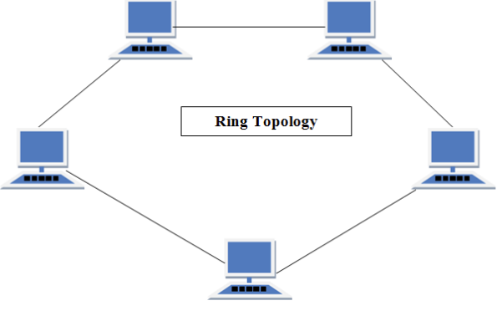
Features of Ring Topology

A number of repeaters are used for Ring topology with large number of nodes, because if someone wants to send some data to the last node in the ring topology with 100 nodes, then the data will have to pass through 99 nodes to reach the 100th node. Hence to prevent data loss repeaters are used in the network.
The transmission is unidirectional, but it can be made bidirectional by having 2 connections between each Network Node, it is called Dual Ring Topology.
In Dual Ring Topology, two ring networks are formed, and data flow is in opposite direction in them. Also, if on7. What is meant by socket?e ring fails, the second ring can act as a backup, to keep the network up.
Data is transferred in a sequential manner that is bit by bit. Data transmitted, has to pass through each node of the network, till the destination node.

Advantages of Ring Topology

Transmitting network is not affected by high traffic or by adding more nodes, as only the nodes having tokens can transmit data.
Cheap to install and expand

7.What is meant by socket?
Ans: Sockets allow communication between two different processes on the same or different machines. To be more precise, it's a way to talk to other computers using standard Unix file descriptors. In Unix, every I/O action is done by writing or reading a file descriptor. A file descriptor is just an integer associated with an open file and it can be a network connection, a text file, a terminal, or something else.
To a programmer, a socket looks and behaves much like a low-level file descriptor. This is because commands such as read() and write() work with sockets in the same way they do with files and pipes.
Sockets were first introduced in 2.1BSD and subsequently refined into their current form with 4.2BSD. The sockets feature is now available with most current UNIX system releases.

Where is Socket Used?

A Unix Socket is used in a client-server application framework. A server is a process that performs some functions on request from a client. Most of the application-level protocols like FTP, SMTP, and POP3 make use of sockets to establish connection between client and server and then for exchanging data.

Socket Types

There are four types of sockets available to the users. The first two are most commonly used and the last two are rarely used.

Processes are presumed to communicate only between sockets of the same type but there is no restriction that prevents communication between sockets of different types.
- Stream Sockets − Delivery in a networked environment is guaranteed. If you send through the stream socket three items "A, B, C", they will arrive in the same order − "A, B, C". These sockets use TCP (Transmission Control Protocol) for data transmission. If delivery is impossible, the sender receives an error indicator. Data records do not have any boundaries.
- Datagram Sockets − Delivery in a networked environment is not guaranteed. They're connectionless because you don't need to have an open connection as in Stream Sockets − you build a packet with the destination information and send it out. They use UDP (User Datagram Protocol).
- Raw Sockets − These provide users access to the underlying communication protocols, which support socket abstractions. These sockets are normally datagram oriented, though their exact characteristics are dependent on the interface provided by the protocol. Raw sockets are not intended for the general user; they have been provided mainly for those interested in developing new communication protocols, or for gaining access to some of the more cryptic facilities of an existing protocol.
Sequenced Packet Sockets − They are similar to a stream socket, with the exception that record boundaries are preserved. This interface is provided only as a part of the Network Systems (NS) socket abstraction, and is very important in most serious NS applications. Sequenced-packet sockets allow the user to manipulate the Sequence Packet Protocol (SPP) or Internet Datagram Protocol (IDP) headers on a packet or a group of packets, either by writing a prototype header along with whatever data is to be sent, or by specifying a default header to be used with all outgoing data, and allows the user to receive the headers on incoming packets.

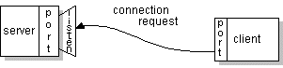

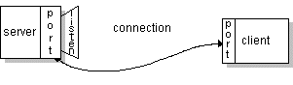

8.Explain TCP and UDP headers?
Ans:
Transmission Control Protocol (TCP) and User Datagram Protocol (UDP) are the two standard transport layers used with internet protocol (IP).
Both TDP and UDP use headers as part of packaging message data for transfer over network connections. TCP headers and UDP headers each contain a set of parameters called fields defined by the protocol technical specifications.

TCP Header Format
Each TCP header has ten required fields totaling 20 bytes (160 bits) in size.
They can also optionally include an additional data section up to 40 bytes in size.
This is the layout of TCP headers:
- source TCP port number (2 bytes)
- destination TCP port number (2 bytes)
- sequence number (4 bytes)
- acknowledgement number (4 bytes)
- TCP data offset (4 bits)
- reserved data (3 bits)
- control flags (up to 9 bits)
- window size (2 bytes)
- TCP checksum (2 bytes)
- urgent pointer (2 bytes)
- TCP optional data (0-40 bytes)
​TCP inserts header fields into the message stream in the order listed above.
- Source and destination TCP port numbers are the communication endpoints for sending and receiving devices.
- Message senders use sequence numbers to mark the ordering of a group of messages. Both senders and receivers use the acknowledgement numbers field to communicate the sequence numbers of messages that are either recently received or expected to be sent.
- The data offset field stores the total size of a TCP header in multiples of four bytes. A header not using the optional TCP field has a data offset of 5 (representing 20 bytes), while a header using the maximum-sized optional field has a data offset of 15 (representing 60 bytes).
- Reserved data in TCP headers always has a value of zero. This field serves the purpose of aligning the total header size as a multiple of four bytes (important for efficiency of computer data processing).
- TCP uses a set of six standard and three extended control flags (each an individual bit representing on or off) to manage data flow in specific situations. One bit flag, for example, initiates TCP connection reset logic. The detailed operation of these fields goes beyond the scope of this article.
- TCP senders use a number called window size to regulate how much data they send to a receiver before requiring an acknowledgement in return. If the window size becomes too small, network data transfer will be unnecessarily slow, while if the window size becomes too large, the network link can become saturated (unusable for any other applications) or the receiver may not be able to process incoming data quickly enough (also resulting in slow performance). Windowing algorithms built into the protocol dynamically calculate size values and use this field of TCP headers to coordinate changes between senders and receivers.
- The checksum value inside a TCP header is generated by the protocol sender as a mathematical technique to help the receiver detect messages that are corrupted or tampered with.
- The urgent pointer field is often set to zero and ignored, but in conjunction with one of the control flags, it can be used as a data offset to mark a subset of a message as requiring priority processing.
- Usages of optional TCP data go beyond the scope of this article but include support for special acknowledgement and window scaling algorithms.

UDP Header Format
Because UDP is significantly more limited in capability than TCP, its headers are much smaller.
A UDP header contains 8 bytes, divided into the following four required fields:
- source port number (2 bytes)
- destination port number (2 bytes)
- length of data (2 bytes)
- UDP checksum (2 bytes)
​UDP inserts header fields into its message stream in the order listed above.
- Source and destination UDP port numbers are the communication endpoints for sending and receiving devices.
- The length field in UDP represents the total size of each datagram including both header and data. This field ranges in value from a minimum of 8 bytes (the required header size) to sizes above 65,000 bytes.
- Similar to TCP, a UDP checksum allows receivers to cross-check incoming data for any corrupted bits of the message.
9.Explain the purpose of CRC/checksum?
Ans: CRC is simple to implement in binary hardware, Mathematical analysis of CRC is very simple, and it is good at detecting common errors caused by noise in transmission.
Cyclic Redundancy Check this is the real name that lies behind the 3 letter acronym CRC. The usage of CRC varies from place to place. This is because only the name is alone standard and the backend algorithm can be coded and implemented for any purpose. The first and foremost reason for CRC is error detection.
When the spot light is thrown on this error detection it is further classified in to two divisions. Cyclic Redundancy Check used for detecting and reducing the transmission errors in the data i.e. In networking data need to be transferred over a wide range among various devices. At that time there are several chances for data being lost during the transmission. To monitor this, sender of that data attached some additional values with the original data and then transmitted it. The additional data is nothing but some polynomial division of a common number. The receiver will use the received data as well as the additional value in reverse process to check whether there is a data loss in the received data or not.
Another place where Cyclic Redundancy Check mechanism is used effectively is data storage in storage drives. Though the data inside a storage drive looks like normal files and folder, they are just a combination of tons of bit and byte binary values. When a data is created in the hard drive, in the upper level it will look like filesystem, files, folders etc. in the low level it will be just zeros and one’s that are filled inside a set of hash tables. Since even a single small file can hold lots of binary valued zeros and ones there are chances of data mislay and data loss. A loss of single value can alter the internal arrangement of a file completely in the raw level.
So a legitimate and resourceful mechanism is needed to look for data loss trails in the hard drive raw data. This is where Cyclic Redundancy Check is employed. Since the data is written in high speed, it will be scattered and stored in different locations of the HDD wherever there is possible space. The index of the scattered data will be created and stored in another part of memory. Along with this a few additional data that are calculated through CRC is also saved.
Whenever a file is clicked by the user in the hard drive, a Cyclic Redundancy Check will be undergone that all the needed data value store din the index file are available for processing or not. Suppose if there is a mismatch in the generated and verified CRC. Then definitely there is data loss. And the OS will indicate errors message like this.
“File open error: invalid CRC”
“Cannot copy file: Data error (Cyclic Redundancy Check)”
“CRC error: The file which you are running may be corrupted.”
If you ever find CRC in your error message, then alarm yourself that the data in the HDD is corrupted.
Advantages:
- This is just a simple code and can be produced and implemented in any form of applications.
- Easy to view single bit errors and multiple burst errors.
- Based on the severity and complexity of the error the error correction mechanism can be generated. This type of mechanism is commonly found in file repairing software and utilities.
Because of its simplicity it can fit any type of operating system and all versions, including the latest.

10.Work on the network commands netstat, net?
Ans:
The netstat command is a Command Prompt command used to display very detailed information about how your computer is communicating with other computers or network devices.
Specifically, the netstat command can show details about individual network connections, overall and protocol-specific networking statistics, and much more, all of which could help troubleshoot certain kinds of networking issues.

Netstat Command Syntax
Netstat [-a] [-b] [-e] [-f] [-n] [-o] [-p protocol] [-r] [-s] [-t] [-x] [-y] [time_interval] [/?]
Tip: See How To Read Command Syntax if you're not sure how to read the netstat command syntax above.
Execute the netstat command alone to show a relatively simple list of all active TCP connections which, for each one, will show the local IP address (your computer), the foreign IP address (the other computer or network device), along with their respective port numbers, as well as the TCP state.
-a = This switch displays active TCP connections, TCP connections with the listening state, as well as UDP ports that are being listened to.
-b = This netstat switch is very similar to the -o switch listed below, but instead of displaying the PID, will display the process's actual file name. Using -b over -o might seem like it's saving you a step or two but using it can sometimes greatly extend the time it takes netstat to fully execute.
-e = Use this switch with the netstat command to show statistics about your network connection. This data includes bytes, unicast packets, non-unicast packets, discards, errors, and unknown protocols received and sent since the connection was established.
-f = The -f switch will force the netstat command to display the Fully Qualified Domain Name (FQDN) for each foreign IP addresses when possible.
-n = Use the -n switch to prevent netstat from attempting to determine host namesfor foreign IP addresses. Depending on your current network connections, using this switch could considerably reduce the time it takes for netstat to fully execute.
-o = A handy option for many troubleshooting tasks, the -o switch displays the process identifier (PID) associated with each displayed connection. See the example below for more about using netstat -o.
-p = Use the -p switch to show connections or statistics only for a particular protocol. You can not define more than one protocol at once, nor can you execute netstat with -p without defining a protocol.
protocol = When specifying a protocol with the -p option, you can use tcp, udp, tcpv6, or udpv6. If you use -s with -p to view statistics by protocol, you can use icmp, ip, icmpv6, or ipv6 in addition to the first four I mentioned.
-r = Execute netstat with -r to show the IP routing table. This is the same as using the route command to execute route print.
-s = The -s option can be used with the netstat command to show detailed statistics by protocol. You can limit the statistics shown to a particular protocol by using the -soption and specifying that protocol, but be sure to use -s before -p protocol when using the switches together.
-t = Use the -t switch to show the current TCP chimney offload state in place of the typically displayed TCP state.
-x = Use the -x option to show all NetworkDirect listeners, connections, and shared endpoints.
-y = The -y switch can be used to show the TCP connection template for all connection. You cannot use -y with any other netstat option.
time_interval = This is the time, in seconds, that you'd like the netstat command to re-execute automatically, stopping only when you use Ctrl-C to end the loop.
/? = Use the help switch to show details about the netstat command's several options.
Tip: Make all that netstat information in the command line easier to work with by outputting what you see on the screen to a text file using a redirection operator.
See How To Redirect Command Output to a File for complete instructions.

Netstat Command Examples
netstat -f
In this first example, I execute netstat to show all active TCP connections. However, I do want to see the computers I'm connected to in FQDN format [-f] instead of a simple IP address.
Here's an example of what you might see:
Active Connections

Proto Local Address Foreign Address State
TCP 127.0.0.1:5357 VM-Windows-7:49229 TIME_WAIT
TCP 127.0.0.1:49225 VM-Windows-7:12080 TIME_WAIT
TCP 192.168.1.14:49194 75.125.212.75:http CLOSE_WAIT
TCP 192.168.1.14:49196 a795sm.avast.com:http CLOSE_WAIT
TCP 192.168.1.14:49197 a795sm.avast.com:http CLOSE_WAIT
TCP 192.168.1.14:49230 TIM-PC:wsd TIME_WAIT
TCP 192.168.1.14:49231 TIM-PC:icslap ESTABLISHED
TCP 192.168.1.14:49232 TIM-PC:netbios-ssn TIME_WAIT
TCP 192.168.1.14:49233 TIM-PC:netbios-ssn TIME_WAIT
TCP [::1]:2869 VM-Windows-7:49226 ESTABLISHED
TCP [::1]:49226 VM-Windows-7:icslap ESTABLISHED
As you can see, I had 11 active TCP connections at the time I executed netstat. The only protocol (in the Proto column) listed is TCP, which was expected because I did not use -a.
You can also see three sets of IP addresses in the Local Address column - my actual IP address of 192.168.1.14 and both IPv4 and IPv6 versions of my loopback addresses, along with the port each connection is using. The Foreign Address column lists the FQDN (75.125.212.75 didn't resolve for some reason) along with that port as well.

Net Commands
The other options for the net command listed above act as commands in and of themselves, with several unique options:
Net Accounts
The net accounts command is used to set password and logon requirements for users.
For example, the net accounts command can be used to set the minimum number of characters that users can set their password to.
Net Computer
The net computer command is used to add or remove a computer from a domain.
Net Config
Use the net config command to show information about the configuration of the Server or Workstation service.
Net Continue
The net continue command is used to restart a service that was put on hold by the net pause command.
Net File
Net file is used to show a list of open files on a server. The command can also be used to close a shared file and remove a file lock.
Net Group
The net group command is used to add, delete, and manage global groups on servers.
Net Help
The net help command is used to get detailed help on each of the net subset commands.
For example, executing net help user shows detailed information about how to use the net user command. Executing net user /help or net user /h accomplishes the same thing.
The standard /? help switch is also available for each net subset command but doesn't provide near the information that /help does.
Net Helpmsg
The net helpmsg is used to display more information about the numerical network messages you might receive when using net commands.
For example, when executing net group on a standard Windows workstation, you'll receive a 3515 help message. To decode this message, type net helpmsg 3515which displays "This command can be used only on a Windows Domain Controller." on screen.
Net Localgroup
The net localgroup command is used to add, delete, and manage local groups on computers.
Net Name
Net name is used to add or delete a messaging alias at a computer.
The net name command was removed in conjunction with the removal of net send beginning in Windows Vista. See the net send command for more information.
Net Pause
The net pause command puts on hold a Windows resource or service.
Net Print
Net print is used to display and manage network print jobs.
The net print command was removed beginning in Windows 7.
According to Microsoft, the tasks performed with net print can be performed in Windows 10, Windows 8, and Windows 7 using the prnjobs.vbs and other cscript commands, Windows PowerShell cmdlets, or Windows Management Instrumentation (WMI).
Net Send
Net send is used to send messages to other users, computers, or net name created messaging aliases.
The net send command is not available in Windows 10, Windows 8, Windows 7, or Windows Vista but the msg command accomplishes the same thing.
Net Session
The net session command is used to list or disconnect sessions between the computer and others on the network.
Net Share
The net share command is used to create, remove, and otherwise manage shared resources on the computer.
Net Start
The net start command is used to start a network service or list running network services.
Net Statistics
Use the net statistics command to show the network statistics log for the Server or Workstation service.
Net Stop
The net stop command is used to stop a network service.
Net Time
Net time can be used to display the current time and date of another computer on the network.
Net Use
The net use command is used to display information about shared resources on the network that you're currently connected to, as well as connect to new resources and disconnect from connected ones.
In other words, the net use command can be used to show the shared drives you've mapped to as well as allow you to manage those mapped drives.
Net User
The net user command is used to add, delete, and otherwise manage the users on a computer.
Net View
Net view is used to show a list of computers and network devices on the network.
Tip: You can save to a file whatever a net command shows on screen using a redirection operator with the command. See How To Redirect Command Output to a File for instructions or see Command Prompt Tricks for more tips.

Net Command Availability
The net command is available from within the Command Prompt in all Windows operating systems including Windows 10, Windows 8, Windows 7, Windows Vista, Windows XP, and more.
Note: The availability of certain net command switches and other net command syntax may differ from operating system to operating system.

Net & Net1
You may have come across the net1 command and wondered what it was, maybe even more baffled that it seems to function exactly like the net command. The reason it seems to act just like the net command is because it is the net command.
Only in Windows NT and Windows 2000 was there a difference in the net command and the net1 command. The net1 command was made available in these two operating systems as a temporary fix for a Y2K issue that impacted the net command.
This Y2K issue with the net command was corrected before Windows XP was even released but you'll still find net1 in Windows XP, Vista, 7, 8, and 10 to maintain compatibility with older programs and scripts that used net1 when it was necessary to do so.

________________________________________________________________________________

Device Drivers

1. How many ways of integrating module to Kernel ?
Ans:.
- Two possible ways of integrating module to kernel:
a. Dynamic Insertion as a kernel module [Modprobe & Insmod]
b. Linking statically to the kernel code
3.Both insmod and modprobe is used to insert kernel module.
3. But everyone will prefer modprobe, because insmod have no capability to resolve dependency issue. But modprobe can do that.
3. While we are installing the module using modprobe, first it will check the dependencies in /lib/modules/<kernel-version>/modules.dep
4. This file contain entire file modules & its corresponding dependencies.
5. Modules.dep file is generated by “depmod” command.

2. How to insert module during run time?
Ans:
1. Dynamically we can insert module during run time.
2. Two ways to insert the module dynamically,
a. Insmod
b. Modprobe
a. Insmod: Following are steps to insert the module using Insmod
1. Write a simple module program, module programming is also called as kernel programming.
For module programming no main function is required.
Start -> init() function
End -> exit() function
2. lsmod -> It will shows the list of module that loaded already.
3. insmod -> Insert the module into the kernel.
Eg. Sudo insmod hello.ko
4. modinfo -> It will display information about the kernel module.
Eg. Modinfo hello.ko
5. Dmesg -> It will display kernel ring buffer information
It will display whatever you added the printk() in module programming, that information.
6. rmmod -> To remove the module
Eg. Sudo rmmod hello

When a module is inseted into the kernel, the module_init macro will be invoked, which will call the function hello_init().
Similarly, when the module is removed with rmmod, module_exit() function will be invoked, which will call hello_exit.
Using dmesg command, we can see th output from the kernel module.

b. Modprobe
Modprobe utility is used to add loadable modules to the kernel.
You can also add and remove module using modprobe copmmand.
Modprobe -l : Display all available module.
Lsmod : currently loaded module
modprobe <module_name> : Install new module
modprobe -r <module_name>: Remove a module
We can also use rmmod , to delete module. But admins prefer modprobe with -r option, because modprobe is clever than insmod and rmmod.

3. What do the commands insmod, lsmod, modinfo, modprobe, rmmod perform?
Ans:
insmod: To insert a module into kernel.
lsmod: It will diaplay information about a list of already loaded kernel module.
modinfo: It will diaplay information about kernel module.
rmmod: To remove a module from the kernel.

4. What is meant by ISR? Why ISR’s are needed for Device Drivers?
Ans:
1. ISR is nothing but the interrupt service routine.
2. The function the kernel runs in response to a specific interrupt is called an interrupt handler or interrupt service routine (ISR).
3. Each device that generates interrupts has an associated interrupt handler.
4. For example, one function handles interrupts from the system timer, whereas another function handles interrupts generated by the keyboard.
5. he interrupt handler for a device is part of the device’s driver—the kernel code that manages the device.
6. In Linux, interrupt handlers are normal C functions.
7. They match a specific prototype, which enables the kernel to pass the handler information in a standard way, but otherwise they are ordinary functions.
8. What differentiates interrupt handlers from other kernel functions is that the kernel invokes them in response to interrupts and that they run in a special context called interrupt context.
9. This special context is occasionally called atomic context because, as we shall see, code executing in this context is unable to block.
10. Because an interrupt can occur at any time, an interrupt handler can, in turn, be executed at any time.
11. For protecting critical sections inside interrupt handlers, you can't use mutexes because they may go to sleep. Use spinlocks instead, and use them only if you must.
12. Interrupt handlers cannot directly exchange data with user space because they are not connected to user land via process contexts.
13. Interrupt handlers are supposed to get out of the way quickly but are expected to get the job done.
14. You need not design interrupt handlers to be reentrant. When an interrupt handler is running, the
corresponding IRQ is disabled until the handler returns. So, unlike process context code, different
instances of the same handler will not run simultaneously on multiple processors.

5. What is meant by IPL’s?
Ans: IPL is nothing but the Interrupt Priority Level.
1. It is the part of the current system interrupt state, which indicates the interrupt rerquests that will currently be accepted.
2. The operating systems' Interrupt Priority Level (IPL) is a software-only scheme that assigns a priority level to every driver/device combination configured in any given system, and also supports hardware interrupts.

6. What are generic driver entry points?
Ans:
1. Every driver must have one common entry point.
2. The entry point is called init_module() in Linux.
3. Remaining entry points for all drivers open(), close(), __init(), __fini(), __info(), attatch(), detach(), getinfo(), probe(), power(),dump(), identify() etc.
7. What are the types of device drivers available?
Ans:
1. There are three types of device driver available.
A: Character Device Driver eg. serial ports, parallel ports, sounds cards
B: Block Device Driver . eg. hard disks, USB cameras, Disk-On-Key.
C: Network Device Driver Eg. Ethernet, wifi etc.

8. How character driver is different from block device driver?
Ans:
A Character ('c') Device is one with which the Driver communicates by sending and
receiving single characters (bytes, octets).
A Block ('b') Device is one with which the Driver communicates by sending entire blocks of data.

9. What is need of top half and bottom half routines (or upper half and lower half)?
Ans:
1. Whenever device driver raise interrupt, isr should process fast and respond to interrupt immediately.
2. After creating data structure for device that called top half and later process other works related to driver in bottom half.
3. Lengthy tasks inside interrupt handler degrade system responsiveness.

a. Top Half: Perform time critical tasks such as acknowledging receipt of interrupt, reseting hardware etc. It is the routine that actually respond to the interrupt –the one you register with request_irq().
b. Bpttom Half: Perform any interrupt related work not performed by interrupt handler. he bottom half is a routine that is scheduled by the top half to be executed later, at a safer time.A bottom half is a low-priority function, usually related to interrupt handling, that is waiting for the kernel to find a convenient moment to run it.

4. The big difference between the top-half handler and the bottom half is that all interrupts are enabled during execution of the bottom half—that’s why it runs at a safer time.
5. In the typical scenario, the top half saves device data to a device-specific buffer, schedules its bottom half, and exits: this operation is very fast.
6. The bottom half then performs whatever other work is required, such as awakening processes, starting up another I/O operation, and so on.
7. This setup permits the top half to service a new interrupt while the bottom half is still working.

10. What are the different types of bottom half routines are available and what is their purpose?
Ans: There are two type of bottom half routines are available:
1] Tasklets: Software interrupt context
2] Softirq:Software interrupt context
2] Workqueue: Process context
1] Tasklets
1.Tasklets are a special function that may be scheduled to run, in software interrupt context, at a system-determined safe time.
2. They may be scheduled to run multiple times, but tasklet scheduling is not cumulative; the tasklet runs only once, even if it is requested repeatedly before it is launched.
3. No tasklet ever runs in parallel with itself, since they run only once, but tasklets can run in parallel with other tasklets on SMP systems.
4. If your driver has multiple tasklets, they must employ some sort of locking to avoid conflicting with each other.
5. Tasklets are also guaranteed to run on the same CPU as the function that first schedules them.
6. Locking between the tasklet and the interrupt handler may still be required.
7. Tasklets must be declared with the DECLARE_TASKLET macro:
DECLARE_TASKLET(name, function, data);
8. Tasklet are often powerful mechanism for bottom half processing, they are very fast, but all tasklet code must be atomic.

2] Workqueue:
1. The alternative tasklet is workqueue, which may have higher latency, but that are allowed to sleep.
2. Since the workqueue function runs in process context, it can sleep if need be.
3. Most important, work queues are schedulable and can therefore sleep.
4. Normally, it is easy to decide between using work queues and softirqs/tasklets.
5. If the deferred work needs to sleep, work queues are used.
6. If the deferred work need not sleep, softirqs or tasklets are used.
7. If you need a schedulable entity to perform your bottom-half processing, you need work queues.
8. They are the only bottom-half mechanisms that run in process context, and thus, the only ones that can sleep.
9. If you do not need a kernel thread to handle your deferred work, consider a tasklet instead.

11. What would copy_from_user() and copy_to_user() functions perform?
Ans:
a. Copy_to_user():
1. Copy a block of data into user space.
2. unsigned long copy_to_user ( void_user *to, const void * from, unsigned long n);
to = Destination address, in user space
from = Source address in kernel space
n = number of byte to copy
3. User context only, this function may sleep.
4. It will copy data from user space to kernael space.
5. Return number of byte that could not be copied. On successd, this will be zero.

b. Copy_from_user():
1. Copy a block of data from user space.
2. unsigned long copy_from_user ( void *to, const void_user * from, unsigned long n);
to = Destination address in kernel space
from = Sourec address in user space
n = Number of bytes to copy.
3. User context only. This function may sleep.
4. Copy data from user space to kernel space.
5. Returns number of bytes that could not be copied. On success, this will be zero.
6. If some data could not be copied, this function will pad the copied data to the requested size using zero bytes.
12. What are the differences between SoftIRQ and Tasklets?
SoftIrq | Tasklet
softirq is guaranteed to run on the CPU it was scheduled on | Tasklets don’t have that guarantee to run on the CPU it was scheduled on
The same SoftIrq can run on two seperate CPU’s at the same time | The same tasklet can not run on two separate CPU’S at the same time [Note- Two different tasklets can run on two different CPU’S, just not the same one]
SoftIRQs are re-entarant | Tasklets are not re-entarant.
SoftIrq can be only created/destroyed statically . | Tasklets can be created/destroyed statically or dynamically

Building Kernel Image

1. What is meant by cross-compilation? How it is different from general compilation?
Ans:
A compiler that runs on one computer but produces object code for a different type of computer. Cross compilers are used to generate software that can run on computers with a new architecture or on special-purpose devices that cannot host their own compilers.
A cross compiler is a compiler capable of creating executable code for a platform other than the one on which the compiler is running. For example, a compiler that runs on a Windows 7 PC but generates code that runs on Android smartphone is a cross compiler.
A cross compiler is necessary to compile for multiple platforms from one machine. A platform could be infeasible for a compiler to run on, such as for the microcontroller of an embedded system because those systems contain no operating system. In par virtualization one machine runs many operating systems, and a cross compiler could generate an executable for each of them from one main source.
Cross compilers are not to be confused with source-to-source compilers. A cross compiler is for cross-platform software development of binary code, while a source-to-source compiler translates from one programming language to another in text code. Both are programming tools.

2)How to communicate to target board, what are the different ways available?
Ans:
The Primary Mode Of Development For Real-Time Embedded Software Has Been The "Host/Target" Approach. In This Approach, The Software For The Application Is Developed On One Computer System To Be Executed On Another. The Increased Memory And Speed Of Embedded Hardware Has Now Reached A Point Where These Systems Are Capable Of Supporting Both Their Real-Time Applications And The Software Engineering Environments For Their Development. This Has Made The Acceptance Of The Higher Risk And Complexity Inherent To The Host/Target Approach An Undesirable Strategy.The Shift Back To Self-Targetted Development For Embedded Software Will Have Important Consequences In The Future Of Software Engineering Environments. It Also Heralds The Emergence Of A New Type Of Computer System: The General Purpose Embedded Computer.
Host -Target System Development Target System Development Approach Approach During development process, a host system is used Then locating and burning the codes in the target board. Target board hardware and software later copied to get the final embedded system Final system function exactly as the one tested and debugged and finalized during the development process

3. Explain the process of building kernel Image (from kernel.org) with the detailed steps.?
Ans:
Linux kernel is the life force of all Linux family of operating systems including Ubuntu, CentOS, and Fedora.
For most part, you don’t need to compile the kernel, as it is installed by default when you install the OS. Also, when there is a critical update done to the kernel, you can use yum, or apt-get to update the kernel on your Linux system.
However you might encounter certain situation, where you may have to compile kernel from source. The following are few situation where you may have to compile Kernel on your Linux system.
To enable experimental features that are not part of the default kernel.
To enable support for a new hardware that is not currently supported by the default kernel.
To debug the kernel
Or, just to learn how kernel works, you might want to explore the kernel source code, and compile it on your own.
In this tutorial, we’ll explain how to compile Linux kernel from source.
Also, please note that if you just want to compile a driver, you don’t need to compile the kernel. You need only the linux-headers package of the kernel.
1. Download the Latest Stable Kernel
The first step is to download the latest stable kernel from kernel.org.
# cd /usr/src/

# wget https://www.kernel.org/pub/linux/kernel/v3.x/linux-3.9.3.tar.xz
2. Untar the Kernel Source
The second step is to untar the kernel source file for compilation.
# tar -xvJf linux-3.9.3.tar.xz
3. Configure the Kernel
The kernel contains nearly 3000 configuration options. To make the kernel used by most people on most hardware, the Linux distro like Ubuntu, Fedora, Debian, RedHat, CentOS, etc, will generally include support for most common hardware. You can take any one of configuration from the distro, and on top of that you can add your own configuration, or you can configure the kernel from scratch, or you can use the default config provided by the kernel.
# cd linux-3.9.3

# make menuconfig
The make menuconfig, will launch a text-based user interface with default configuration options as shown in the figure. You should have installed “libncurses and libncurses-devel” packages for this command to work.
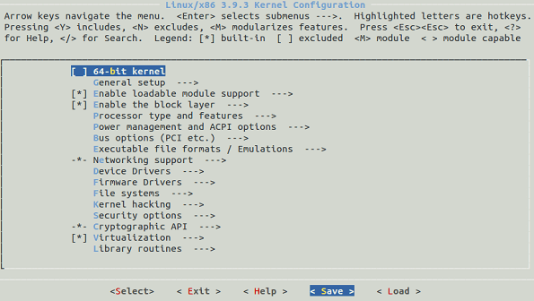
We will use the default config provided by the kernel. So select “Save” and save the config in the file name “.config”.
The following is a sample of the “.config” file:
CONFIG_MMU=y
CONFIG_NEED_DMA_MAP_STATE=y
CONFIG_NEED_SG_DMA_LENGTH=y
CONFIG_GENERIC_ISA_DMA=y
CONFIG_GENERIC_BUG=y
CONFIG_GENERIC_HWEIGHT=y
4. Compile the Linux Kernel
Compile the main kernel:
# make
Compile the kernel modules:
# make modules
Install the kernel modules:
# make modules_install
At this point, you should see a directory named /lib/modules/3.9.3/ in your system.
5. Install the New Kernel
Install the new kernel on the system:
# make install
The make install command will create the following files in the /boot directory.
vmlinuz-3.9.3 – The actual kernel
System.map-3.9.3 – The symbols exported by the kernel
initrd.img-3.9.3 – initrd image is temporary root file system used during boot process
config-3.9.3 – The kernel configuration file
The command “make install” will also update the grub.cfg by default. So we don’t need to manually edit the grub.cfg file.
6. Boot Linux to the new Kernel
To use the new kernel that you just compiled, reboot the system.
# reboot
Since, in grub.cfg, the new kernel is added as default boot, the system will boot from the new kernel. Just in case if you have problems with the new kernel, you can select the old kernel from the grub menu during boot and you can use your system as usual.
Once the system is up, use uname command to verify that the new version of Linux kernel is installed.

4. Work on the building Kernel Image with YOCTO?
Ans:
git clone git://git.yoctoproject.org/poky.git

cd $HOME/yocto-labs/poky

git checkout -b pyro-17.0.0 pyro-17.0.0

Return to your project root directory (cd $HOME/yocto-labs/) and download the OpenEmbed-ded TI layer:

git clone git://git.yoctoproject.org/meta-ti.git

cd $HOME/yocto-labs/meta-ti
git checkout -b pyro eb53d577228a1aa77d9c279021d3e0066bc7a1c8

git am $HOME/yocto-labs/0001-Simplify-linux-ti-staging-recipe.patch

Set up the build environment
Check you’re using Bash. This is the default shell when using Ubuntu.
Export all needed variables and set up the build directory:
cd $HOME/yocto-labs/poky/
source oe-init-build-env
You must specify which machine is your target. By default it is qemu. We need to build an image for a beaglebone. Update the MACHINE configuration variable accordingly. Be careful, beaglebone is different from the beagleboard machine

Build your first image
Now that you’re ready to start the compilation, simply run: bitbake core-image-minimal
Once the build finished, you will find the output images under
$BUILDDIR/tmp/deploy/images/beaglebone

Set up the SD card
In this first lab we will use an SD card to store the bootloader, kernel and root filesystem files. Before copying the images on it, we first need to set up the partition layout. You will find a bash script to do so, under
$HOME/yocto-labs/script/.
Execute it:
umount /dev/mmcblk0*sudo ./format_sdcard.sh /dev/mmcblk0
Once this is finished, remove the SD card, then insert it again, it should automatically be
mounted.You can now copy the two U-Boot stages, the Linux kernel image and the compiledm device tree in the boot partition.
cp $BUILDDIR/tmp/deploy/images/beaglebone/{MLO,u-boot.img,zImage} \
/media/$USER/boot
cp $BUILDDIR/tmp/deploy/images/beaglebone/zImage-am335x-boneblack.dtb \
/media/$USER/boot/dtb
Now uncompress the generated rootfs in the second partition with the following
tar command:
sudo tar xpf $BUILDDIR/tmp/deploy/images/beaglebone/\
core-image-minimal-beaglebone.tar.xz -C /media/$USER/rootfs
sync

sudo apt-get install picocom
sudo adduser $USER dialout
Configure the U-Boot environment and boot
setenv bootcmd 'mmc rescan; fatload mmc 0 0x80200000 zImage; fatload mmc 0
0x82000000 dtb; bootz 0x80200000 - 0x82000000'
setenv bootargs 'console=ttyO0,115200 root=/dev/mmcblk0p2 rw'
saveenv
Finally you can start the kernel using the U-Boot command boot.

ARM

1. Explain ARM architecture?
Ans:
1. ARM statnd for Advanced RISC Machine.
2. It supports RISC architecture.
3. It use only two control signal Memory Read and Memory Write.
4. Support Pipeline.
5. In single clock, execution of multiple instruction.
6. Same address for I/O and Memory.
7. Emphasis on Software
8. Fast performance
9. Low power consumption.
10. Support Load and store Instruction set.
11. Use for specific purpose application.
12. Complexity in compiler.
13. ARM having total 4 profile
A. Classic Processor
B. Cortex-M Serries
C. Cortex-R serries
D. Cortes-A serries
14. Within the device the componant are connected together using AMBA bus.
15. AMBA specifies two buses:
A. High perforamance system bus AXI: For connecting peripherals
B. Low power bus APB : For memory Interface

16. ARM having total 37 register set.

2. Explain differences between CISC and RISC
Ans:

 | RISC | CISC
Instruction Type | Simple | Complex
Opeartion of on instuction | One cycle | More cycle
Instruction format | Fixed | Variable
Instruction Execution | In parallel | In sequential
Addressing mode | Simple | Complex
Instruction accessing the memory | Only two, Load and Store | Almost All from the Set.
Register Set | Multiple | Unique
Complexity | In Compiler | In CPU
Address bus | Same address bus for IO and Memory | Different address bus for memory and IO
Emphasis | More important to software | More important to hardware
Power Consumption | Less | More
Transistor | Require less transistor to function | Require more transistor to function
Application | Specific purpose applicatio | General Purpose Application
Example | Cell phone etc. | Desktop PC etc.

3. Explain different modes in ARM?
Ans:
1. Arm support total 7 processor mode.
2. These mode are seperated into two parts:
A: Previledge Mode: Full read and write access to CPSR
B: Non-Previledge Mode: Only read access to CPSR
A: Previledge Mode
1. Supervisor Mode
2. Fast Interrupt Request [FIQ] Mode
3. Interrupt Request [IRQ] Mode
4. Abort Mode
5. Undefined Mode
6. System Mode
B:Non-Previledge Mode
1. User Mode
1. Supersior Mode:Entered on reset and when supervisor call instruction is executed.
Supervisor mode is the mode that the processor is in after reset and is generally the mode that an operating system kernel operates in.
2. Fast Interrupt Request [FIQ]:Entered when high priority interrupt is raised
3. Interrupt Request Mode [IRQ]: Entered when normal priority interrupt is raised
4. Abort Mode : The processor enters abort mode when there is a failed attempt to access memory
5. Undefined Mod: Used to handle undefined instruction.Undefined mode is used when the processor encounters an instruction that is undefined or not supported by the implementation.
6. System Mode: System mode is a special version of user mode that allows full read-write access to the cpsr.
7. User Mode : User mode is used for programs and applications

4. Explain pipelining in ARM?
Ans:
1. ARM support 3-stage, 5-stage, 8-stage,and 13-stage pipelining.
2. Normal 3 stage pipeline is show in following figure:
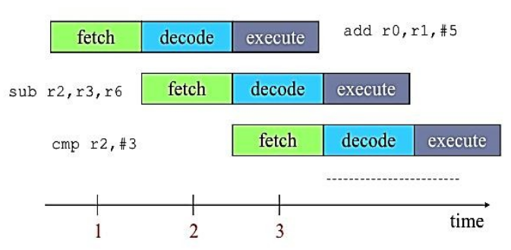
3. In first cycle add instruction fetch from memory
4. In second cycle add instruction is decoded and at the same time sub instruction is fetched from memory
5. In third cycle add instruction will execute , sub instruction will decode and new instruction i.e cmp will fetch from mamory.
6. In this way by using pipeline we can execute multiple instruction in single cycle.

5. Explain Linux boot sequence in case of ARM architecture?
Ans: Following are the steps for Linux booting sequence in case of ARM architecture:
1. Initiall switch on the power
2. BIOS
It stands for Basic input output system
Performs some system integrity checks
Searches, loads, and executes the boot loader program.
It looks for boot loader in floppy, cd-rom, or hard drive. You can press a key (typically F12 of F2, but it depends on your system) during the BIOS startup to change the boot sequence.
Once the boot loader program is detected and loaded into the memory, BIOS gives the control to it.
So, in simple terms BIOS loads and executes the MBR boot loader.
In this step basic hardware initialization takes place.
Location and execution will be at ROM only.
3. MBR
It stands for Master Boot Record
It is located in the 1st sector of the bootable disk. Typically /dev/hda, or /dev/sda
It contains information about GRUB (or LILO in old systems).
So, in simple terms MBR loads and executes the GRUB boot loader.
4. GRUB
GRUB stands for Grand Unified Bootloader.
If you have multiple kernel images installed on your system, you can choose which one to be executed.
GRUB displays a splash screen, waits for few seconds, if you don’t enter anything, it loads the default kernel image as specified in the grub configuration file.
So, in simple terms GRUB just loads and executes Kernel and initrd images.
5. Kernel
Mounts the root file system as specified in the “root=” in grub.conf
Kernel executes the /sbin/init programKernel executes the /sbin/init program
Since init was the 1st program to be executed by Linux Kernel, it has the process id (PID) of 1.
Initrd stands for Initial RAM Disk.
Initrd is used by kernel as temporary root file system until kernel is booted and the real root file system is mounted. It also contains necessary drivers compiled inside, which helps it to access the hard drive partitions, and other hardware
Mount root file system.
6. Init
Looks at the /etc/inittab file to decide the Linux run level
Following are the available run levels
- 0 – halt
- 1 – Single user mode
- 2 – Multiuser, without NFS
- 3 – Full multiuser mode
- 4 – unused
- 5 – X11
- 6 – reboot
Init identifies the default initlevel from /etc/inittab and uses that to load all appropriate program.
Typically you would set the default run level to either 3 or 5.
7. Runlevel programs
When the Linux system is booting up, you might see various services getting started. For example, it might say “starting sendmail …. OK”. Those are the runlevel programs, executed from the run level directory as defined by your run level.
Under the /etc/rc.d/rc*.d/ directories, you would see programs that start with S and K.
Programs starts with S are used during startup. S for startup.
Programs starts with K are used during shutdown. K for kill.
There are numbers right next to S and K in the program names. Those are the sequence number in which the programs should be started or killed.
________________________________________________________________________________

